BIM USEs and use CASEs

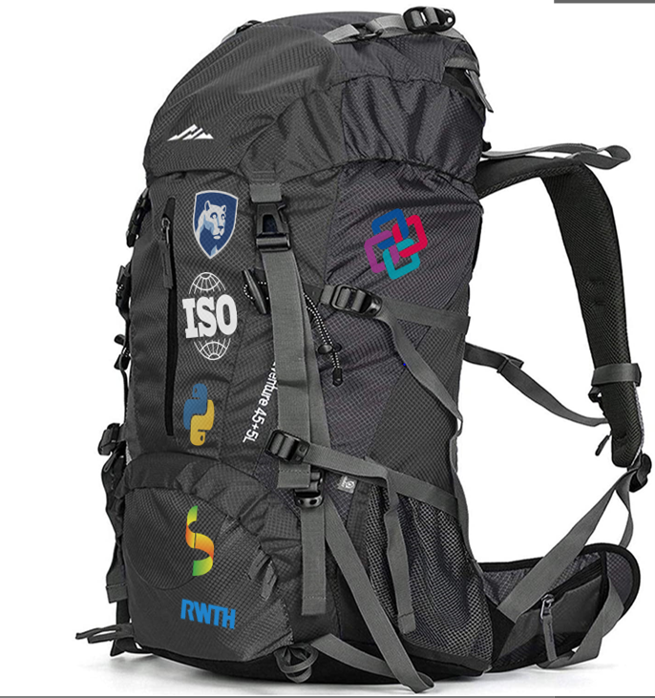

Advanced Building Information Modelling

11034 Autumn 2020 DTU Byg

Tim Pat McGinley

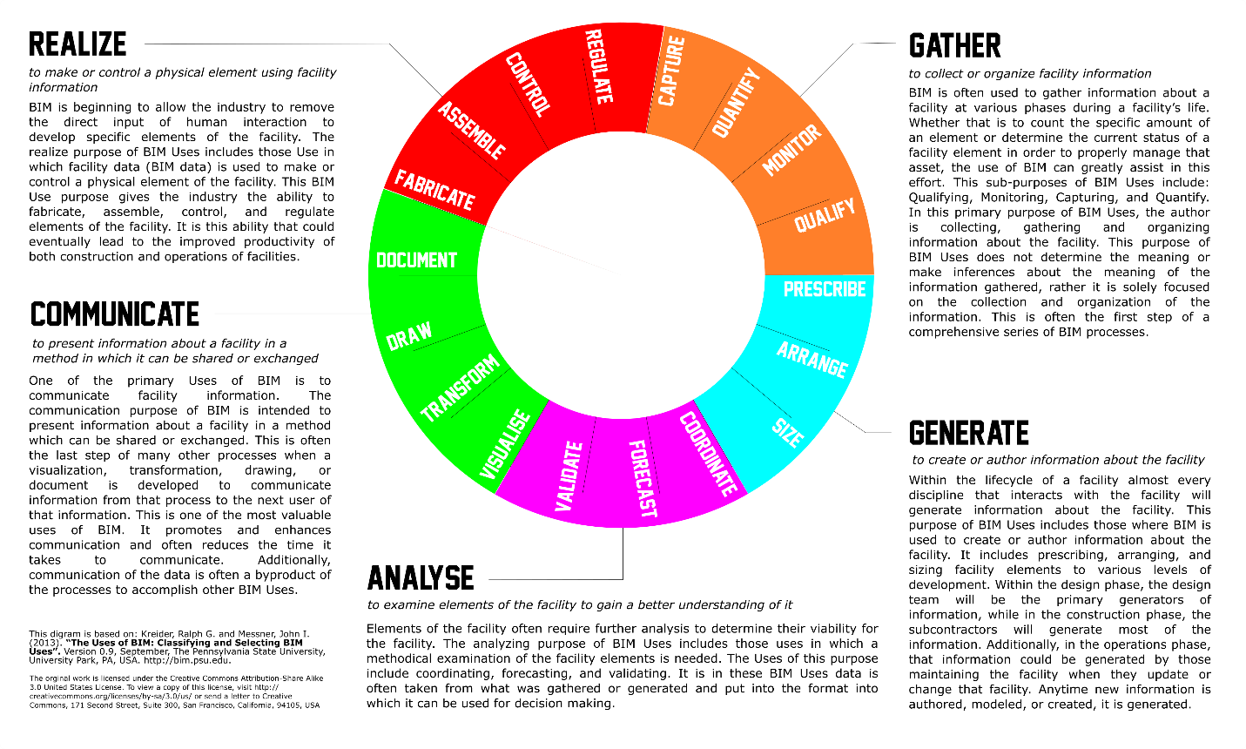

Contents

Introduction 1

What we learnt from the IFC Rules assignment 1

Assignment 3 2

What to actually submit…. 2

Deadline 2

23 Purposes 3

18 Use Cases 3

Mapping BIM uses, use cases and processes 4

BIM Uses 5

BIM Use Purpose Primary and Secondary Categories 5

BIM Use Purpose: Gather 6

Gather: Capture 8

Gather: Quantify 8

Gather: Monitor 9

Gather: Qualify 9

BIM Use Purpose: Generate 10

Generate: Prescribe 11

Generate: Arrange 11

Generate: Size 12

BIM Use Purpose: Analyze 13

Analyse: Coordinate 14

Analyse: Forecast 14

Analyse : Validate 15

BIM Use Purpose: Communicate 16

Communicate : Visualise 17

Communicate : Transform 17

Communicate : Draw 18

Communicate : Document 18

BIM Use Purpose: Realise 19

Realise : Fabricate 20

Realise : Assemble 20

Realise : Control 21

Realise : Regulate 21

Use cases 22

Use Cases: Plan 24

01: Existing Conditions Modelling 25

02: Cost Estimation 26

03: Phase Planning (4D Modelling) 27

04: Programming 28

05: Site Analysis 29

06: Design Authoring 30

07: Design Review 31

Use Cases : Design 32

08: Structural Analysis 33

09: Lighting Analysis 34

10: Energy Analysis 35

11: Sustainability Analysis 36

12: Code Validation 37

13: Design Coordination 38

Use Cases : Build 39

14: Site Utilization Planning 40

15: Construction System Design 41

16: Digital Fabrication 42

17: 3D Control and Planning 43

Use Cases : Use / Occupation 44

18: Record Modelling 45

19: Maintenance Scheduling 46

20: Building System Analysis 47

21: Asset Management 48

22: Space Management 49

23: Disaster Planning and Mitigation 50

Phases 50

ISO 19650 Process 51

Information Delivery Manual 52

MVD 53

Picture credits

Gather: <https://www.landtechinc.com/services/3d-laser-scanning/>

Generate: <https://www.youtube.com/watch?v=NL1KAvbVpEU&ab_channel=Design%26Motion.net>

Analyse: <https://www.autodesk.com/products/robot-structural-analysis/overview?plc=AECCOL&term=1-YEAR&support=ADVANCED&quantity=1>

Communicate:<https://www.vgis.io/augmented-reality-esri-gis-ar-for-construction-bentley-microstation-autodesk-cad/>

Realize:<https://www.designboom.com/architecture/robarch-2018-fabio-gramazio-interview-robotic-fabrication-08-21-2018/>

Digital Fabrication: <https://www.designboom.com/architecture/robarch-2018-fabio-gramazio-interview-robotic-fabrication-08-21-2018/>

Disaster Planning and Mitigation: <https://politiken.dk/indland/art5898745/Storbrand-fik-brandbiler-fra-Gladsaxe-til-at-dr%C3%B8ne-mod-Jylland>

Sustainability Analysis: <https://www.ribaj.com/products/open-source-embodied-carbon-construction-calculator-co2-emissions-stephen-cousins>

Code Validation: <https://bygningsreglementet.dk/>

Asset Management: <https://www.shielsexton.com/qr-code-technology-in-the-field/>

## Introduction

In the IFC Rules exercise, you developed rules to satisfy 3 of the 18 use cases presented in the Penn State Use case guide. To achieve this you extended the skills, knowledge and experience you developed in the first IFC Dashboard assignment by developing skills in coding in Python and using the Ifcopenshell library to design simple Python programs that automate BIM rules of IFC files.

To achieve this we did not spend very much time looking at the use cases but instead focused on what it was possible for you to write as a rule. We use the Penn State cases because they offer a broad view of BIM and also excitingly, they have been written so that they are copy right free and can be reproduced. So why do we care about use cases and what was the point or the rules exercise? Well, the use cases are work that needs to done, tasks that need to be performed in the lifecycle of a building.

The big shift that we propose in BIM and the AEC is the shift to viewing these tasks as services that need to be performed. What is exciting about this approach is that it enables two new ways to engage in the industry the first is offering the potential to procure and sub contract clearly defined processes in the AEC. This will enable companies to both offer and procure a great range of services, some of these could be of varying size. Also it offers the opportunity to automate the services both in the design and construction of the building. In fact a healthy way to think of these services is to design them so that they can be performed either automatically (as python scripts for instance) by robots on site or by human designers and builders.

The potential for automation differs in the BIM use case and we could argue that few of them do not imply a ‘human in the loop’ to at least check the result. Therefore here we want you to extend the Penn State Use cases presented here to provide a detailed use case that could be followed both by humans and computers ( by code for instance) However you will not need to do the actual programming here, but consider what you would need to achieve this. What your information requirements / information need is for this use case.

Therefore in this assignment you will dig deeper into use cases and some tools and standards to support this and develop two BIM use case that extends provide a real example of for of BIM use that you can then use to develop your final project (you will choose one of these BIM uses for the final project). In this process we can imagine the diagram we saw in the previous booklet as

## What we learnt from the IFC Rules assignment

1. That it is possible to write our own programs to check rules in BIM
2. That it is very important to have a clear use case in mind when developing BIM tools or assessing the best approach from a selection of existing tools.
3. It is easier to get the properties than it was in the excel example.
4. It can still take a long time to work out what we need to do in order to achieve our goal and test the rule we have decided on.
5. There are overlaps between the use cases and some scripts and functions could be capable of supporting more than one use case.
6. It is a great idea to have a format like IFC that supports interoperability in the AEC but working with IFC is complicated, however if we can get our heads around this complexity .

# Assignment 3

We want you to focus on Advanced BIM isn’t about going in and changing everything all at once, but really focusing on a specific use case and getting that right and in the process setting up the foundations to support work in further use cases without actually doing it. In this way we reduce the potential to overstretch and also provide you with an opportunity to demonstrate the potential value that you offer to a company quickly and in a controlled space.

We are also really interested in presenting BIM as a method for you to explore the things that interest you. Therefore, in this assignment we want you to identify 2 use cases that you are really passionate about and want to explore further. One of these will end up being the one that you choose in your final project.

In this assignment you will dig deeper into use cases and some tools and standards to support this and develop two BIM use case that extends provide a real example of a BIM use that you can then use to develop your final project (you will choose one of these BIM uses for the final project).

*Therefore the core of the assignment is:* For each of the two selected use cases, produce An A4 report. Therefore, the assignment report should include as many pages as are required to concisely convey your use cases.

|  |
| --- |
| For each use case upload |
| * Report (documenting sections 1,2,3,5,6,7)   + Use_case_report_Team_XX.pdf * Information exchange excel sheet (for section 4)   + Use_case_INFX_Team_XX.xlsx * Bpmn file of current use case (redrawn by you) + BPMN file for your proposed tool   + NAME_OF_USE_CASE_Team_XX.bpmn   + NAME_ OF_PROPOSED_PROCESS_Team_XX.bpmn |

## What to actually submit….

For each of your chosen use cases, write a report based on the BIM Execution Plan from Penn State. However our report is a bit different as it includes the plan for the development of a new tool / workflow. It should include the following stages.

**1) Goal**

Goal of the tool / workflow in one sentence.

i.e. to support the user to calculate the total total cost of the project.

**2) Model Use (Bim Uses)**

Please refer initially to the **Mapping BIM uses, use cases and processes** section in this document.

**3) Process**

1) model the process diagram from your use case in BPMN.io please remember to save the .bpmn file and you can save a .svg file that you can insert into your report.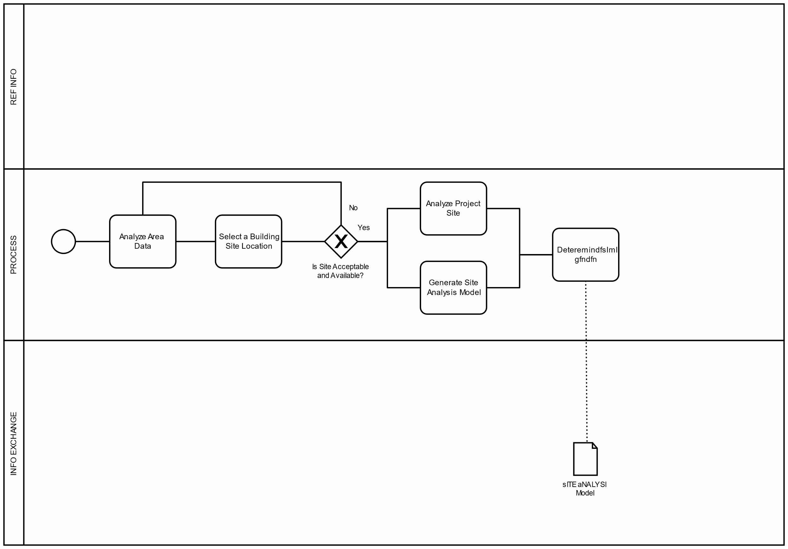

2) description of the **process** of your tool / workflow

Link to original process maps [here](https://psu.pb.unizin.org/app/uploads/sites/189/2019/05/Template-Process-Maps-V2-0-MS-Powerpoint-Format.ppt).

**4) Information Exchange**

Fill out the excel template with the information for your planned tool / workflow. For this you will need access to the excel, which we will provide ASAP and the Dikon document to help you specify the LOD (LOR,LOG,LOI) for each element you need for you tool / workflow. This can get confusing - don’t worry we can help 😊

**5) Your tool / workflow**

Description of how your tool / workflow would solve the use case

**6) IFC**

Describe the IFC entities and properties for each of the elements you identified in your information exchange.

**7) How you would make it (tool development methodology)**

Description of how you would make the tool / workflow - what steps would you go through?

**Deadline: 01 November 23:30**

# 23 Use Cases

|  |
| --- |
| Existing conditions modelling |
| Cost Estimation |
| Phase Planning |
| Programming |
| **Site Analysis** |
| Design Authoring |
| **Design Review** |
| **Structural Analysis** |
| **Lighting Analysis** |
| **Energy Analysis** |
| Sustainability Analysis |
| Code Validation |
| **Design Coordination** |
| Site Utilization Planning |
| Construction System Design |
| Digital Fabrication |
| 3D Control and Planning |
| **Record Modelling** |
| Maintenance Scheduling |
| **Building System Analysis** |
| Asset Management |
| Space Management |
| Disaster Planning and Management |

18 Model / BIM Uses

*Gather*

Capture

Quanitify

Monitor

Qualify

*Generate*

Prescribe

Arrange

Size

*Analyse*

Coordinate

Forecast

Validate

*Communicate*

Visualise

Transform

Draw

Document

*Realize*

Fabricate

Assemble

Control

Regulate4 Phases

*Based on ISO 22263 as used in*

Plan

Portfolio Requirements

Conception of need

Outline feasibility

Substantive feasibility

Design

Outline conceptual design

Full conceptual design

Coordinated Design (and procurement)

Build

Production Information

Construction

Use

# Mapping BIM uses, use cases and processes

|  |  |  |  |  |  |  |  |  |  |  |  |  |  |  |  |  |  |
| --- | --- | --- | --- | --- | --- | --- | --- | --- | --- | --- | --- | --- | --- | --- | --- | --- | --- |
| **BIM Use cases** | | | **Uses** | | | | | **Phases** | | | | | | | | | |
| [**BIM Uses by Project Phase**](https://www.bim.psu.edu/bim_uses/) | BXP Process Diagram |  | Gather | Generate | Analyse | Communicate | Realize | Plan | | | Design | | | Build | | Use | |
| **01: Existing conditions modelling** | **Existing conditions modelling** |  | **Capture** |  |  |  |  |  | | |  | | |  | |  | |
| 02: Cost Estimation | Cost Estimation |  | **Quantify** |  | Forecast |  |  |  | | |  | | |  | |  | |
| 03: Phase Planning |  |  |  | Prescribe | Forecast |  |  |  | | |  | | |  | |  |  |
| 04: Programming | Programming |  |  | Prescribe  Arrange  Size | Forecast |  |  |  | | |  | | |  |  |  |  |
| **05: Site Analysis** | **Site Analysis** |  | **Qualify** |  |  |  |  |  | | |  | |  |  |  |  |  |
| 06: Design Authoring | Design Authoring |  |  | Arrange  Size  Draw |  |  |  |  |  | |  | | |  |  |  |  |
| **07: Design Review** | **Design Review** |  |  |  |  | **Review** |  |  |  |  |  | | |  |  |  |  |
| **08: Structural Analysis** | **Structural Analysis** |  |  |  | **Forecast** |  |  |  |  |  |  | | |  |  |  |  |
| **09: Lighting Analysis** | **Lighting Analysis** |  |  |  | **Forecast** |  |  |  |  |  |  | | |  |  |  |  |
| **10. Energy Analysis** | **Energy Analysis** |  |  |  | **Forecast** |  |  |  |  |  |  | | |  |  |  |  |
| 11: Sustainability Analysis |  |  |  |  | Forecast |  |  |  |  |  |  | | |  | |  |  |
| 12: Code Validation |  |  |  |  | Validate |  |  |  |  |  |  | | |  |  |  |  |
| **13: Design Coordination** | **Design Coordination** |  |  |  | **Coordinate** |  |  |  |  |  |  |  | |  | |  |  |
| 14: Site Utilization Planning | Site Utilization Planning |  |  | Arrange | **Coordinate**  **Forecast** |  |  |  |  |  |  |  | |  | |  |  |
| 15: Construction System Design |  |  |  | Prescribe |  |  | Assemble |  |  |  |  |  | |  | |  |  |
| 16: Digital Fabrication |  |  |  |  |  |  | Fabricate |  |  |  |  |  |  |  | |  |  |
| 17: 3D Control and Planning | 3D Control and Planning |  |  |  |  |  |  |  |  |  |  |  |  |  | |  |  |
| **18: Record Modelling** | **Record Modeling** |  |  |  |  | **Document** |  |  |  |  |  |  |  |  |  |  |  |
| 19: Maintenance Scheduling | Maintenance Scheduling |  |  |  |  |  |  |  |  |  |  |  |  |  |  |  | |
| **20: Building System Analysis** | **Building System Analysis** |  |  |  | **Validate** |  |  |  |  |  |  |  |  |  |  |  |  |
| 21: Asset Management |  |  |  |  |  |  | Control  Regulate |  |  |  |  |  |  |  |  |  |  |
| 22: Space Management |  |  | **Monitor** | Prescribe  Arrange | Coordinate  Forecast  Validate | Visualise | Regulate |  |  |  |  |  |  |  |  |  |  |
| 23:Disaster Planning and Management |  |  |  |  |  | **Visualise**  **Document** | Regulate |  |  |  |  |  |  |  |  |  |  |

BIM Uses

This section of the document is based on the ‘[uses of BIM’](https://www.bim.psu.edu/download/the_uses_of_bim.pdf) report from Penn State University. It provides a great overview of the uses or what also be described as the affordances of BIM. What BIM enables (affords) the user to be able to do. So they are different from use cases which talk about specific examples of problems that could be solved with by using BIM. This section discusses how we can use BIM to solve those problems. Both uses and use cases are provided in this booklet, but we start with BIM uses. The original document refers to this as the BIM Use Classification System and Structure. It describes a BIM use as

*‘a method of applying Building Information Modelling during a facility’s lifecycle to achieve one or more specific objectives.’*

Characteristics

BIM Use Characteristics are used to more precisely define the BIM Use beyond the purpose and objective alone. The characteristics to be defined, as shown in Table 3-1, include the facility element(s), facility phase(s), discipline(s), and level of development. Adding these characteristics move the BIM Use beyond answering “why” to a more distinct description which could be used in procurement efforts. Additionally, when BIM planning, a team can communicate to all the stake holders who, what, when, and to what degree the BIM Use will be implemented. Depending on the facility’s BIM utilization, it is possible to have multiple disciplines implement multiple BIM Use purposes during multiple phases on multiple facility elements to multiple levels of development. For example, Coordination Analysis can be implemented during design and construction by the designer and contractor to a level of development 300 and 400. Therefore creating two separate instances of a BIM Use.

Facility Element

*The system of the facility on which the BIM Use will be implemented.*

It is necessary to determine on which facility elements the BIM Use(s) will be executed. Based on [OmniClass Table 21: Elements](https://www.csiresources.org/standards/omniclass) or other applicable element breakdown structures, the team can determine which facility elements are part of the BIM use. For example, the team may determine that it only necessary to develop a schedule visualization of the substructure and superstructure and not the systems of the facility. The top level of this table include: 01) Substructure, 02) Shell, 03) Interiors, 04) Services, 05) Equipment and Furnishings, 06) Special Construction and Demolition, and 07) Sitework.

Facility Phase

*The point in the facility’s lifecycle at which the BIM Use will be implemented.*

Discipline

The discipline is also synonymous with the responsible party for the BIM Use. OmniClass Table 33: Disciplines7 presents standard disciplines. These disciplines could also correspond with the various project roles. At a top level, the disciplines currently in this table include planning, design, investigation, project management, construction, facility use, and support. While the primary discipline may be identified, this does not preclude other disciplines from being responsible for part of the BIM Use. Additionally it is possible to have multiple disciplines responsible for the BIM Use. This would then make for separate BIM Uses.

Level of Development

The degree of granularity to which the BIM Use will be implemented.

For each of the BIM Uses, the level of development should be identified in order to maximize the benefit from the BIM Use. The Level of Development describes the level of detail / granularity to which a Model Element is developed. AIA / BIMForum has recently released a major revision to the level of development specification. This revision further specifies level of development for specific elements of the facility. Table 3-2 shows a description of the Level of Development definitions.

# BIM Use Purpose Primary and Secondary Categories

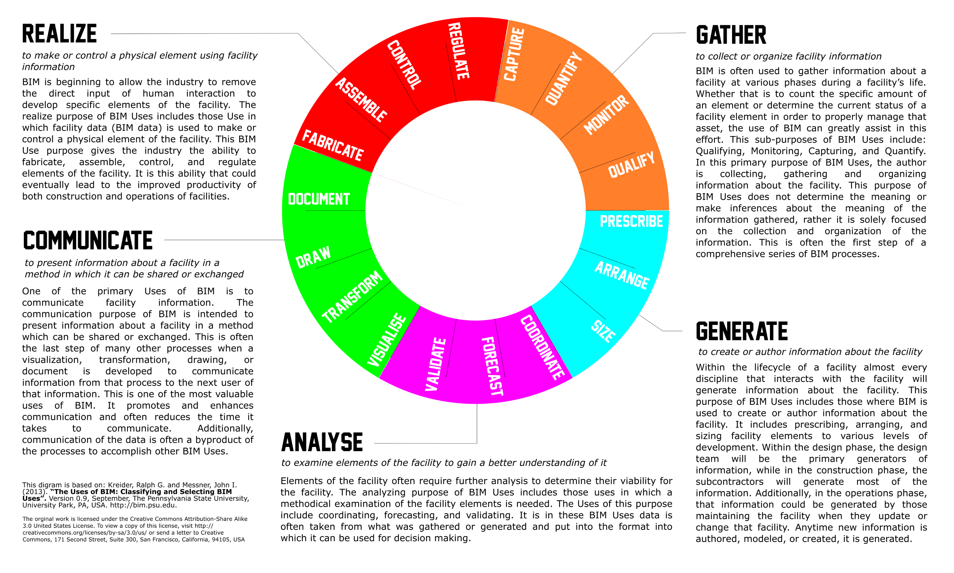

# BIM Use Purpose: Gather (input)

*Objective: to collect or cull facility information. Synonyms: administer, collect, manage, and acquire.*

Description: BIM is often used to gather information about a facility at various phases during a facility’s life. Whether that is to count the specific amount of an element or determine the current status of a facility element in order to properly manage that asset, the use of BIM can greatly assist in this effort. This sub-purposes of BIM Uses include: Qualifying, Monitoring, Capturing, and Quantify. In this primary purpose of BIM Uses, the author is collecting, gathering and organizing information about the facility. This purpose of BIM Uses does not determine the meaning or make inferences about the meaning of the information gathered, rather it is solely focused on the collection and organization of the information. This is often the first step of a comprehensive series of BIM processes.

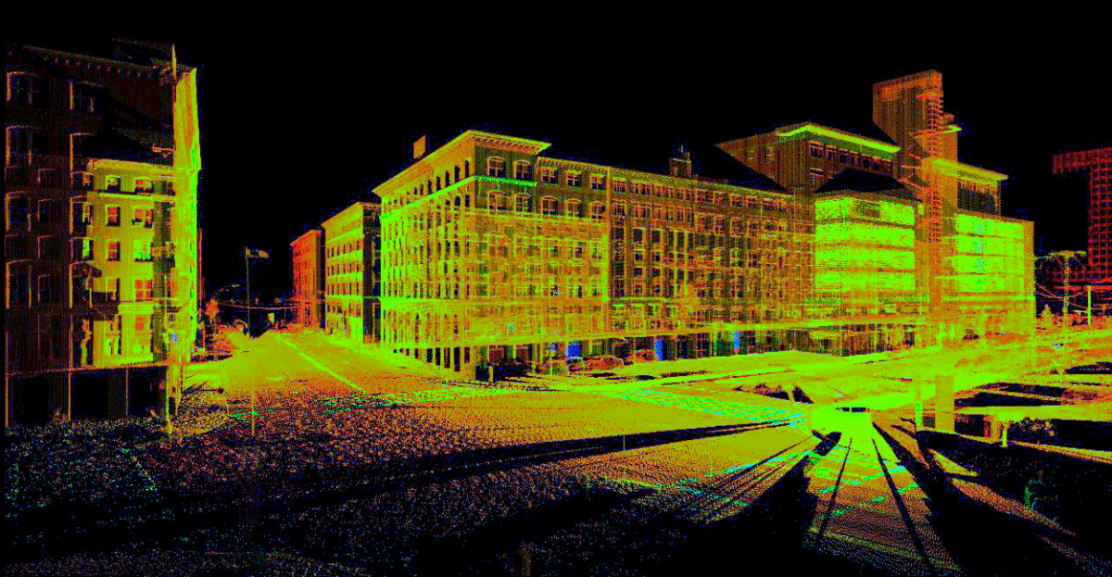

## Gather: Capture

*Objective: to represent, or preserve the current status of the facility and facility elements.*

*Synonyms: collect.*

Description: BIM is often used to capture geometric and attribute data about a facility. This can be done using a number of methods and at a number of points during the life of a facility: the elements of the site prior to the development of a new facility or the conditions of an existing facility prior to renovation. Data could be captured using a laser scanner or recorded manually by inputting model and serial numbers into a spreadsheet. The common factor within this purposes of BIM Uses is that data is captured where no data existed prior. However, it is not newly generated information, rather creating a record of the facility elements that exists.

## Gather: Quantify

*Objective: to express or measure the amount of a facility element.*

*Synonyms: takeoff, count.*

Description: In this purpose of BIM Uses, BIM is used for counting or collecting the amount of specific facility elements. This purpose is often used as part of the estimating and cost forecasting process. During the design phase of a facility, quantities maybe be defined broadly, represented by a range and subject to change. In the construction phase, quantities become more certain and in the operations phase, quantities of elements can be readily calculated, say for instance. For example, the area of carpet to be replaced or the vacant space which is available and rentable, the exact area and dimensions should be known.

## Gather: Monitor

*Objective: to observe the performance of facility elements and systems.*

*Synonyms: observe, measure.*

Description: BIM can be used to monitor real-time performance data of facility elements and facility activities. This purpose of BIM Uses includes those domain uses in which BIM is implemented to understand the performance of particular facility elements or processes. For example, during the operations phase of a facility, BIM can be used to monitor the temperature of a space. It is in this purpose of BIM Uses where Building Automation System data is integrated with the BIM data. Or in construction, BIM could be used to monitor the productivity of a construction process. It is in this purpose of BIM Uses that dynamic real-time data is collected to support decision making.

## Gather: Qualify

*Objective: to characterize, or identify facility elements status.*

*Synonyms: follow, track, identify.*

Description: For this BIM Use Purpose, the status of a facility element is tracked. This includes information such as: does this element exist within the facility? How is it working? This BIM Use Purpose tracks facility elements over time. For example, in design, what is the element’s level of development? In construction, has the element been fabricated? Is it installed? Is it damaged? During operations, this BIM Use Purpose can collect warranty information on the element and whether or not the element is reaching the end of its useful life.

# BIM Use Purpose: Generate

*Objective: to create or author information about the facility. Synonyms: create, author, model.*

Description: Within the lifecycle of a facility almost every discipline that interacts with the facility will generate information about the facility. This purpose of BIM Uses includes those where BIM is used to create or author information about the facility. It includes prescribing, arranging, and sizing facility elements to various levels of development. Within the design phase, the design team will be the primary generators of information, while in the construction phase, the subcontractors will generate most of the information. Additionally, in the operations phase, that information could be generated by those maintaining the facility when they update or change that facility. Anytime new information is authored, modelled, or created, it is generated.

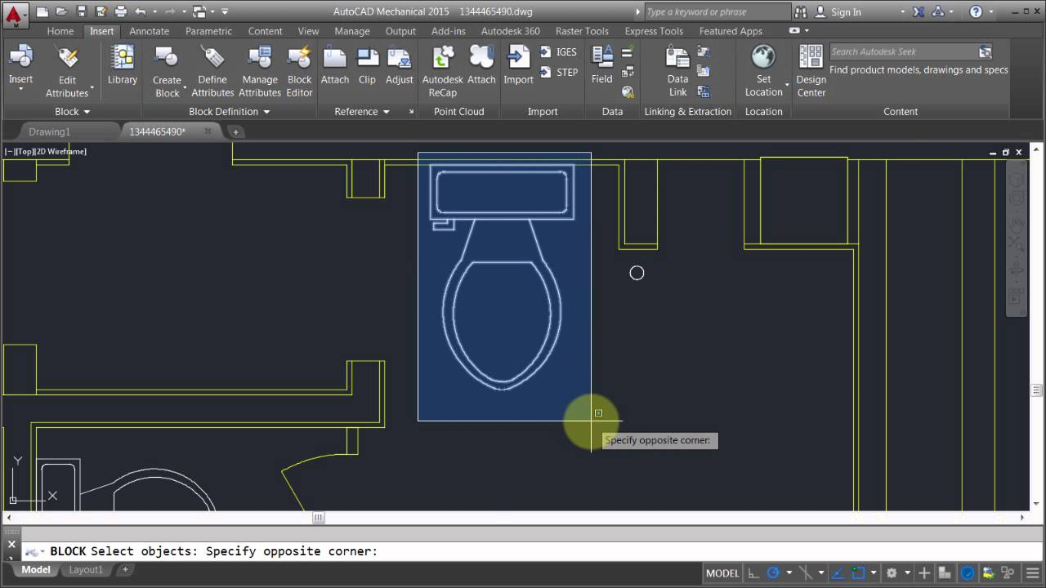

## Generate: Prescribe

*Objective: to determine the need for and select specific facility elements.*

*Synonyms: program, specify, select.*

Description: The prescribing purpose of BIM Uses is used when a generator determines there is a need for a specific facility element. The programmer or architect of the facility may prescribe the need for certain rooms or spaces in the facility. While the mechanical engineer may prescribe the need for a specific HVAC system. The contractor could determine the need for a temporary construction element such as a tower crane, and the operator of the facility may prescribe a specific replacement part for the facility. The element prescribed depends on a number of factors such as phase, discipline, and level of development.

## Generate: Arrange

*Objective: to determine location and placement of facility elements.*

*Synonyms: configure, lay out, locate, place.*

Description: The arranging purpose of BIM Uses includes those Uses in which a location or configuration of a facility element is determined. During the planning phase of a facility's life, this could be the arrangement or adjacency of specific spaces within a proposed facility. During the design phase, it could be the general location of fire protection piping. While in the construction phase, it could include the placement of the hangers that support that piping. This could also be used during the operations phase to determine the placement of furniture systems. In general terms, any time a geometric location of element is determine, it is being arranged.

## Generate: Size

*Objective: to determine the magnitude and scale of facility elements.*

*Synonyms: scale, engineer.*

Description: The sizing purpose of BIM Uses is in use when the magnitude of a facility element is determined. Some of those elements during design could include the dimensions of spaces, the shape of a steel beam, or the size of ductwork. During construction, it could include the size of a crane or the thickness of duct insulation. Additionally, during operations, facility managers record the size of replacement parts or modifications to the facility.

# BIM Use Purpose: Analyze

*Objective: to create or author information about the facility.*

*Synonyms: create, author, model.*

Description: Within the lifecycle of a facility almost every discipline that interacts with the facility will generate information about the facility. This purpose of BIM Uses includes those where BIM is used to create or author information about the facility. It includes prescribing, arranging, and sizing facility elements to various levels of development. Within the design phase, the design team will be the primary generators of information, while in the construction phase, the subcontractors will generate most of the information. Additionally, in the operations phase, that information could be generated by those maintaining the facility when they update or change that facility. Anytime new information is authored, modelled, or created, it is generated.

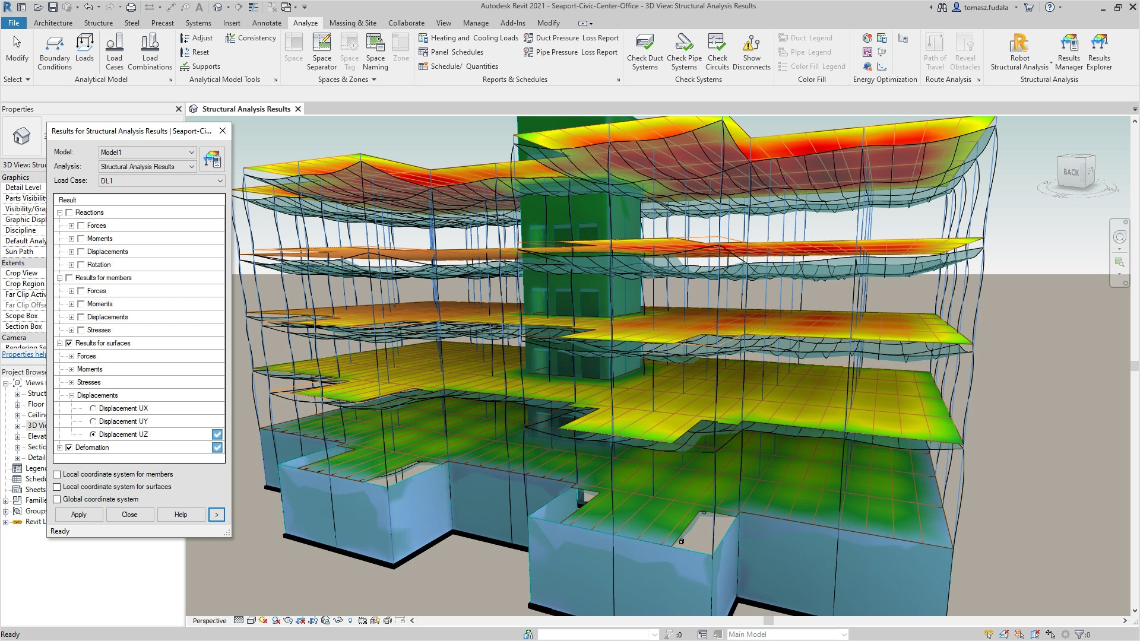

## Analyse: Coordinate

*Objective: to ensure the efficiency and harmony of the relationship of facility elements*

*Synonyms: detect, avoid.*

Description: The coordinating purpose of BIM Uses include those uses where facility elements are analyzed to ensure their relationship to other elements is effective and in harmony. This purpose of BIM Uses is often called clash detection, collision avoidance, design coordination, and interference management, among others. Ultimately, all of the facility elements should work in conjunction with one another. This can include coordinating design intent of various systems during design, coordinating fabrication and installation during construction or coordinating existing operations while renovations are underway. Overall this purpose of BIM uses ensures that the facility will fit together as it is planned and that all the various systems have been considered.

Clash detection stuff

## Analyse: Forecast

*Objective: to predict the future performance of the facility and facility elements.*

*Synonyms: simulate, predict.*

Description: This purpose of BIM Uses is one of the largest and has the most variance in its application from element to element. Within this purpose of BIM Uses, detail analysis is conducted to predict future performance of the facility and facility elements. Some of the primary performance factors that should be considered include financial, energy, flow, scenario, and temporal. Financial forecasting includes cost estimation of first cost of construction as well as **the life cycle cost of a facility**. Energy forecasting predicts how future energy consumption and flow forecasting predicts performance such as air flow or occupant/crowd circulation. Scenario forecasting predicts performance of the facility during emergencies, such as fire, flood, evacuation, and others. Temporal forecasting predicts the performance of the facility over time to include building degradation and the timing for element replacement. Together this purpose of BIM Uses examines multiple facility variables predicts facility performance.

Simulations

Factors

## Analyse : Validate

*Objective: to check or prove accuracy of facility information and that is logical and reasonable.*

*Synonyms: check, confirm*.

Description: This purpose of BIM Uses is implemented to validate facility information. This includes purpose checking facility information for accuracy to ensure that it is logical and reasonable. The validating BIM Uses fall into three primary areas: prescription, functionality, and compliance validation. Prescription validation ensures that facility has the elements that were specified and programmed within the facility including the primary element of facility spaces or rooms. The purpose of functionality validation is to ensure that the facility is constructible, maintainable, and usable. Will the facility perform the purpose for which it has been designed? Compliance validation confirms a facility's compliance with codes and standards to include building codes, ADA standards, sustainability standards and others. Anytime facility information that was developed in another process is checked for accuracy, it falls into the category of validating.

Resources

BR18:

Lokalplan?

# BIM Use Purpose: Communicate

Objective: to present information about a facility in a method in which it can be shared or exchanged. Synonyms: exchange.

Description: One of the primary Uses of BIM is to communicate facility information. The communication purpose of BIM is intended to present information about a facility in a method which can be shared or exchanged. This is often the last step of many other processes when a visualization, transformation, drawing, or document is developed to communicate information from that process to the next user of that information. This is one of the most valuable uses of BIM. It promotes and enhances communication and often reduces the time it takes to communicate. Additionally, communication of the data is often a byproduct of the processes to accomplish other BIM Uses.

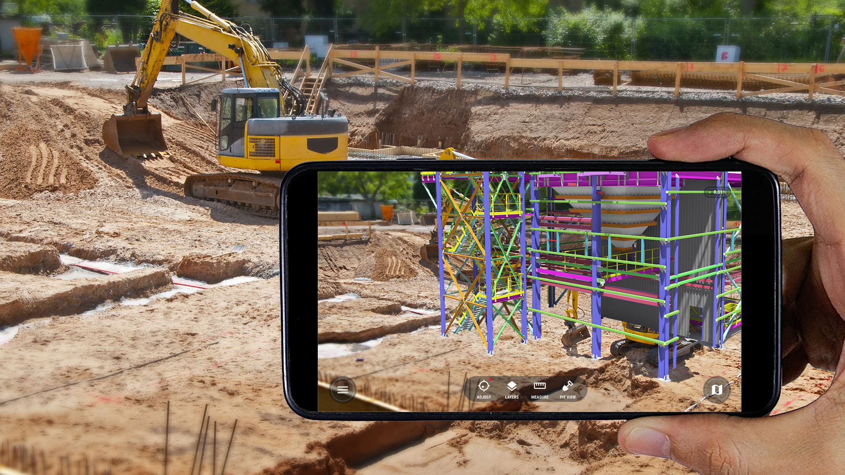

## Communicate : Visualise

*Objective: to form a realistic representation of a facility or facility elements*

*Synonyms: review*

Description: As part of the communication purpose of BIM Uses, using BIM to better visualize a facility is very powerful. It is especially powerful for those who have not been trained within the design and construction industry but are critical stakeholders and decision makers. The visualization purpose of BIM Uses include those BIM Uses which are implemented to form a representation of the facility or facility elements. Often this visualization can be very realistic and detailed in nature. Visualization is often used to support decision making about the facility's design or construction as well as support marketing efforts. It can include walkthroughs, renderings, and schedule visualizations. The fact that the visualization is a by product of other BIM processes improves the ability of individuals to share facility information in a more effective manner with much additional effort.

DASHBOARD??

## Communicate : Transform

*Objective: to modify information and translate it to be received by another process.*

*Synonyms: translate.*

Description: Often within the BIM process, facility information needs to be taken from one form to another so that it can be received and used by another process. This translation or transformation of data allows for interoperability between different systems. It also allows legacy data to be used by current infrastructure. Some examples include developing spooling information, developing layout data, and developing industry standard formats. Often this translated data is in manner in which it is not human interoperable, but readable by machine.

Shifitng data from one form to another? not super exciting but maybe there si something in it?

It could be taking different perspectives on the data?

## Communicate : Draw

*Objective: to make a symbolic representation of the facility and facility elements.*

*Synonyms: draft, annotate, detail.*

Description: While it might be possible to one day rid the industry of drawings and paper, this is not the case today. With that said, BIM improves the ability to develop drawings including detailing and annotating them. These are developed in a parametric method rather static methods. For example, when the BIM model is updated, the corresponding drawings and sheets are also updated. Anytime a symbolic representation is developed from an intelligent model, it is considered a drawing. This includes isometric, one line diagrams, figures and all other symbolic representations.

This could be a new interface - i.e. in VR?

## Communicate : Document

*Objective: to create a record of facility information including the information necessary to precisely specify facility elements*

*Synonyms: specify, submit, schedule, report.*

Description: Often times it is necessary to record facility data in a written narrative or tabular format. The document purpose of BIM Uses includes uses in which a record of facility data is created. This includes those Uses necessary to precisely specify facility elements. The output of this BIM Use often includes specifications, submittals, design schedules, and other reporting of facility data.

# BIM Use Purpose: Realise

Objective: to make or control a physical element using facility information Synonyms: implement, perform, execute,

Description: BIM is beginning to allow the industry to remove the direct input of human interaction to develop specific elements of the facility. The realize purpose of BIM Uses includes those Use in which facility data (BIM data) is used to make or control a physical element of the facility. This BIM Use purpose gives the industry the ability to fabricate, assemble, control, and regulate elements of the facility. It is this ability that could eventually lead to the improved productivity of both construction and operations of facilitie

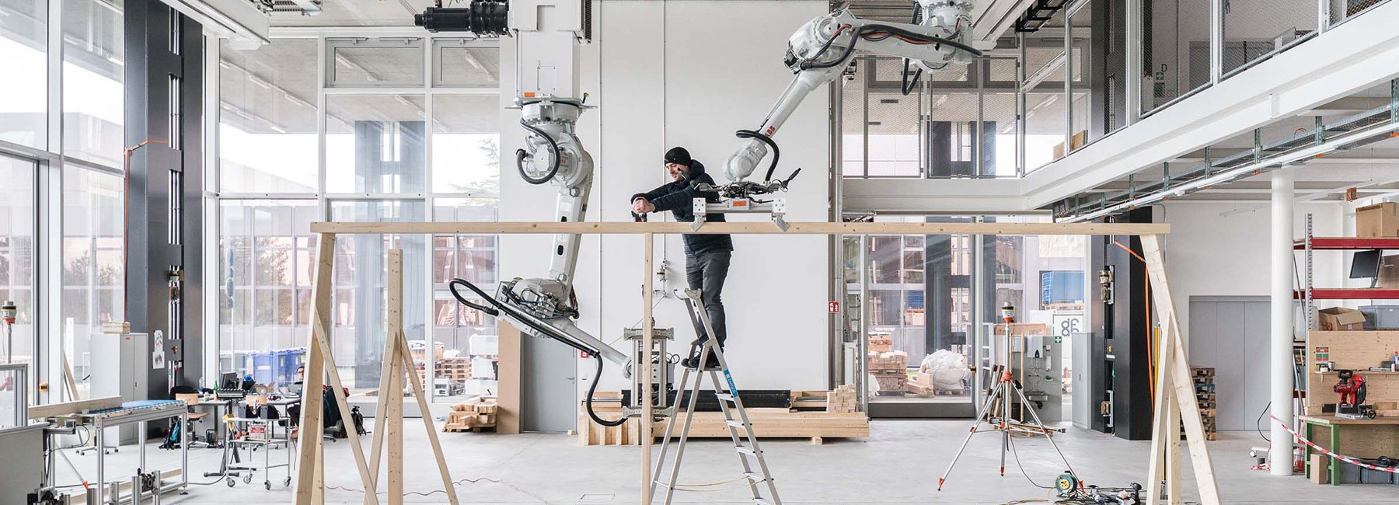

## Realise : Fabricate

*Objective: to use facility information to manufacture the elements of a facility.*

*Synonyms: manufacture.*

Description: BIM is allowing the industry to develop facility elements that were not possible prior to detail product modeling. The fabricate purpose of BIM Uses include those Uses in which facility information is directly used to manufacture elements of the facility. For example, facility information can be used to directly fabricate structural steel shapes from a CNC Machine or directly fabricate ductwork or cut piping. Within the design phase, BIM can be used to quickly generate prototypes of future facility elements, while in operations it could be used to quickly fabricate replacement parts.

This could eb really cool!!!

## Realise : Assemble

*Objective: to use facility information to bring together the separate elements of a facility.*

*Synonyms: prefabricate.*

Description: The assembling purpose of BIM Uses include those uses where facility information is made available to bring together the separate elements of a facility. While still somewhat of a manual process, the precision that BIM allows, ensures that different systems can be prefabricated. It even gives the ability to fit together systems that were traditionally very separate. Some common example include curtain wall systems, energy/MEP cores, and restrooms.

Robtos? / Automation?

lego Manual?

Alexander Gale- Heiede **VDC**

## Realise : Control

*Objective: to use facility information to physically manipulate the operation of executing equipment.*

*Synonyms: manipulate.*

Description: BIM affords the ability to use facility information to control equipment operations. The controlling purpose of BIM Uses include those Uses in which facility information is used to physically manipulate the operation of executing equipment. Some common examples include using facility information to lay-out future work within a facility such as the location of walls or the future placement of imbeds in composite decks. Another example is using facility information to control executing equipment: determining stakeout area using GPS systems which is tied to excavating equipment. It is the ability to control executing equipment that could one day lead to the automated construction site.

## Realise : Regulate

*Objective: to use facility information to inform the operation of a facility element.*

*Synonyms: direct.*

Description: The use of BIM to regulate facility elements potentially allows facility operators to optimize their operations. The regulating purpose of BIM uses include those in which facility information is used to inform the operation of a facility element. A common example of this is when information gathered from a temperature monitor (or thermostat) is used to alter the output of the HVAC system. A critical component of the process is that the data is tied to intelligent monitoring systems and the building information model. This allows the systems to make informed decisions based on the entire system. It is this purpose of BIM Uses which could eventually lead to fully automated operations of a facility.

Use cases

Something about use cases here

BPMN

This focusses on the good stuff with BPMN.

# Use Cases: Plan

This includes several stages from the Description of services 2018

## 9.11 Cost analyses

Preparation of special estimates carried out according to the client’s special requirements. Calculations of the cost consequences of alternative scenarios. Preparation of operating budgets according to the client’s guidelines. Preparation of investment plans and profitability calculations. Preparation of whole-life cost assessments or whole-life cycle cost calculations comprising capitalisation of the overall construction and operating costs during the building’s lifetime.

## 9.6 Bill of quantities

The service comprises the preparation of bills of quantities, and a description of the measuring methods applied. The service must be defined in an ICT specification.

3.1.4 Programming In cooperation with the design manager, the consultant assists in preparing and updating the service plan. In cooperation with the design manager, the consultant contributes to preparing main time schedule for the tendering and construction of the building project. The main time schedule must comprise milestones for the tendering phase, milestones for contract negotiations with the contractor(s), milestone for presentation of the contractors’ work schedules, milestone for preparation of an overall detailed time schedule for the construction, milestones for the client’s approvals, project conference and subsequent consultant design and contractor design, mobilisation and construction and for commissioning and test of technical facilities, preliminary inspection, delivery, etc.

## Project review (Design scrutiny)

Project review means a coherent and systematic review of a project as part of quality assurance with a view to assessing the project’s ability to meet the pro- ject requirements and identifying relevant problems.

## 01: Existing Conditions Modelling

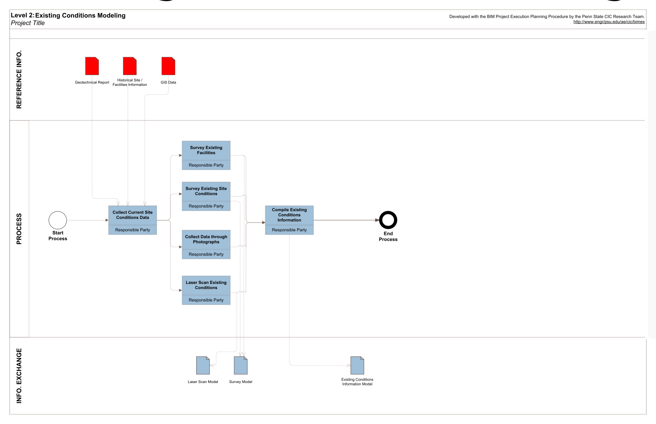

Output 1

Output 2

Description

A process in which a project team develops a 3D model of the existing conditions for a site, facilities on a site, or a specific area within a facility. This model can be developed in multiple ways including laser scanning, photogrammetry and/or conventional surveying techniques, depending on what is desired and what is most efficient. Once the model is constructed, it can be queried for information, whether it is for new construction or a modernization project.

Potential Value

* Enhance the efficiency and accuracy of existing conditions documentation
* Provide documentation of environment for future uses
* Aid in future modeling and 3D design coordination
* Provide an accurate representation of work that has been put into place
* Verify project status with quantity information for progress monitoring
* Provide detailed layout information
* Pre-disaster and post-disaster planning and documentation
* Visualize current and future facility status and plans

Resources Required

* Building Information Model authoring software
* Laser scanning point cloud manipulation software
* 3D Laser scanning
* Conventional surveying equipment

Team Competencies Required

* Ability to manipulate, navigate, and review a 3D model
* Knowledge of Building Information Model authoring tools
* Knowledge of 3D laser scanning tools
* Knowledge of conventional surveying tools and equipment
* Ability to sift through mass quantities of data that is generated by a 3D laser scan
* Ability to determine what level of detail will be required to add “value” to the project
* Ability to generate Building Information Model from 3D laser scan and/or conventional survey data

References for Additional Information

United States General Services Administration (2009). “GSA Building Information Modeling Guide Series: 03 - GSA BIM Guide of 3D Imaging.” [[link](https://www.gsa.gov/real-estate/design-construction/3d4d-building-information-modeling/bim-guides/bim-guide-03-3d-imaging)]

Arayici, Y. (2008). "Towards building information modeling for existing structures." Structural Survey  26.3: 210. ABI/INFORM Global. [[link](https://www.emeraldinsight.com/doi/abs/10.1108/02630800810887108)]

Murphy, M., McGovern, E., and Pavia, S. (2009)."Historic building information modelling (HBIM)." Structural Survey  27.4: 311. ABI/INFORM Global.

Adan, A., Akinci, B., Huber, D., Pingbo, Okorn, B., Tang, P. and Xiong, X. (2010).“Using Laser Scanners for Modeling and Analysis in Architecture, Engineering, and Construction.”

Potential Output Information

* 3D point cloud of existing building
* Surface model of existing geometric elements
* Parametric model including data regarding existing building components

Source:  BIM Project Execution Planning Guide, Ver. 2.2 with minor revisions.

## 02: Cost Estimation

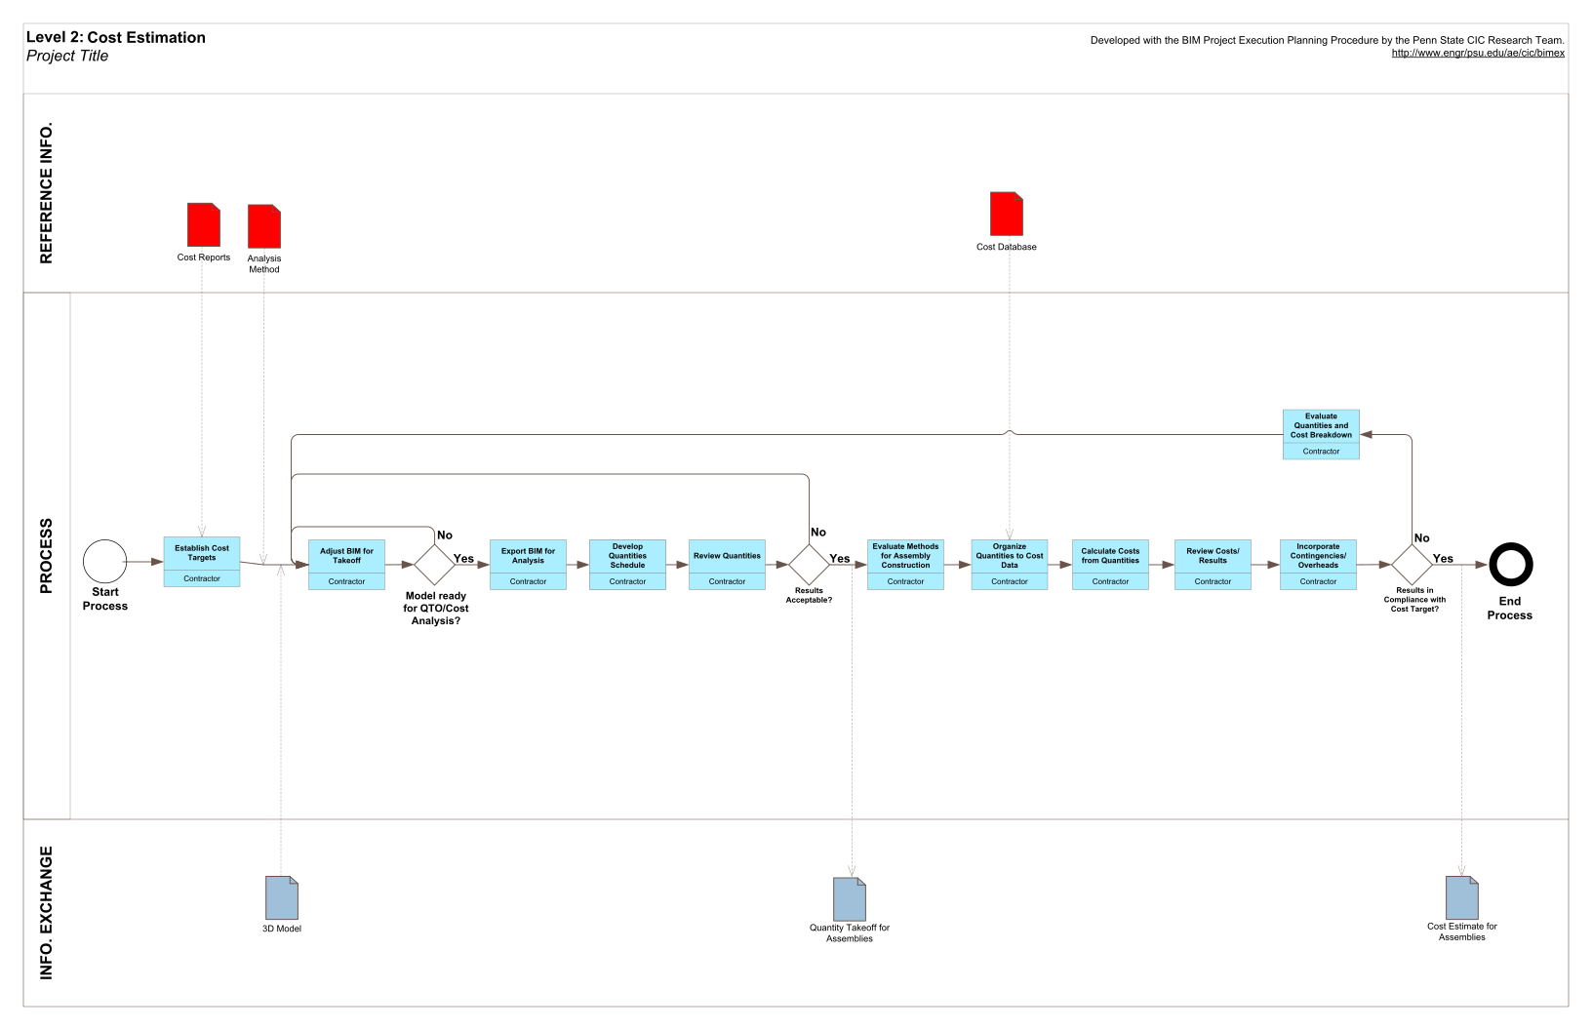

Output 1

Output 2

Description

A process in which BIM can be used to assist in the generation of accurate quantity take-offs and cost estimates throughout the lifecycle of a project. This process allows the project team to see the cost effects of their changes, during all phases of the project, which can help curb excessive budget overruns due to project modifications. Specifically, BIM can provide cost effects of additions and modifications, with potential to save time and money and is most beneficial in the early design stages of a project.

Potential Value

* Precisely quantify modeled materials
* Quickly generate quantities to assist in the decision making process
* Generate more cost estimates at a faster rate
* Better visual representation of project and construction elements that must be estimated
* Provide cost information to the owner during the early decision making phase of design and throughout the lifecycle, including changes during construction
* Saves estimator's time by reducing quantity take-off time
* Allows estimator's to focus on more value adding activities in estimating such as: identifying construction assemblies, generating pricing and factoring risks, which are essential for high quality estimates
* Added to a construction schedule (such as a 4D Model), a BIM developed cost estimate can help track budgets throughout construction
* Easier exploration of different design options and concepts within the owner's budget
* Quickly determine costs of specific objects
* Easier to train new estimators through this highly visual process

Resources Required

* Model-based estimating software
* Design authoring software
* Accurately built design model
* Cost data (Including Masterformat and Uniformat data)

Team Competencies Required

* Ability to define specific design modelling procedures which yield accurate quantity take-off information
* Ability to identify quantities for the appropriate estimating level (e.g. ROM, SF, etc.) upfront
* Ability to manipulate models to acquire quantities usable for estimation

References for Additional Information

Lee, H., Lee, Kim, J. (2008). A cost-based interior design decision support system for large-scale housing projects, ITcon Vol. 13, Pg. 20-38, http://www.itcon.org/2008/2

Autodesk Revit. (2007) "BIM and Cost Estimating." Press release. Autodesk. 11 Sept. 2008. http://images.autodesk.com/adsk/files/bim_cost_estimating_jan07_1_.pdf

Dean, R. P., and McClendon, S. (2007). "Specifying and Cost Estimating with BIM." ARCHI TECH. Apr. 2007. ARCHI TECH. 13 Sept. 2008. http://www.architechmag.com/articles/detail.aspx?contentid=3624.

Khemlani, L. (2006). "Visual Estimating: Extending BIM to Construction." AEC Bytes. 21 Mar. 2006. 13 Sept. 2008. http://www.aecbytes.com/buildingthefuture/2006/visualestimating.html

Buckley, B. (2008). "BIM Cost Management." California Construction. June 2008. 13 Sept. 2008.

Manning, R.; Messner, J. (2008). Case studies in BIM implementation for programming of healthcare facilities, ITcon Vol. 13, Special Issue Case studies of BIM use, Pg. 246-257, http://www.itcon.org/2008/18

Shen Z, Issa R R A (2010) Quantitative evaluation of the BIM-assisted construction detailed cost estimates, Journal of Information Technology in Construction (ITcon), Vol. 15, pg. 234-257, http://www.itcon.org/2010/18

McCuen, T. (2009, November 18). Cost Estimating in BIM: The Fifth Dimension. Retrieved September 21, 2010, from Construction Advisor Today: http://constructionadvisortoday.com/2009/11/cost-estimating-in-bim-the-fifth-dimension.htm

Potential Output Information

Quantity Takeoff Information in Defined Structure

Cost Estimate

Source:  BIM Project Execution Planning Guide, Ver. 2.2 with minor revisions.

## 03: Phase Planning (4D Modelling)

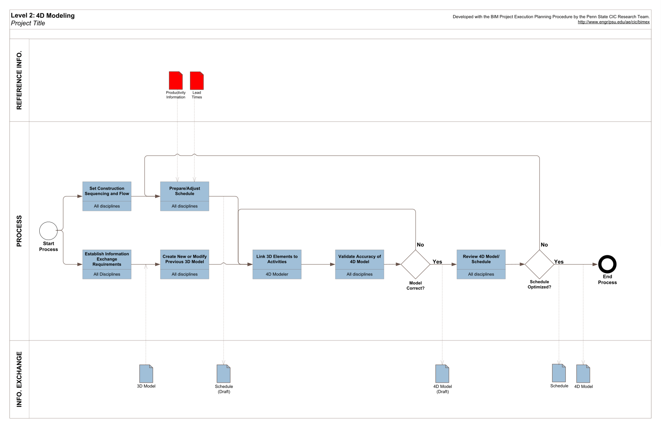

Output

Description

A process in which a 4D model (3D models with the added dimension of time) is utilized to effectively plan the phased occupancy in a renovation, retrofit, addition, or to show the construction sequence and space requirements on a building site. 4D modeling is a powerful visualization and communication tool that can give a project team the including owner a better understanding of project milestones and construction plans.

Potential Value

* Better understanding of the phasing schedule by the owner and project participants and showing the critical path of the project
* Dynamic phasing plans of occupancy offering multiple options and solutions to space conflicts
* Integrate planning of human, equipment and material resources with the BIM model to better schedule and cost estimate the project
* Space and workspace conflicts identified and resolved ahead of the construction process
* Marketing purposes and publicity
* Identification of schedule, sequencing or phasing issues
* More readily constructible, operable and maintainable project
* Monitor procurement status of project materials
* Increased productivity and decreased waste on job sites
* Conveying the spatial complexities of the project, planning information, and support conducting additional analyses

Resources Required

* Design Authoring Software
* Scheduling software
* 4D Modelling Software

Team Competencies Required

* Knowledge of construction scheduling and general construction process.Â  A 4D model is connected to a schedule, and is therefore only as good as the schedule to which it is linked.
* Ability to manipulate, navigate, and review a 3D model.
* Knowledge of 4D software: import geometry, manage links to schedules, produce and control animations, etc.

References for Additional Information

Dawood, N., and Mallasi, Z. (2006).Â  Construction Workplace Planning: Assignment and Analysis Utilizing 4D Visualization Technologies.Â  Computer-aided Civil and Infrastructure Engineering, pp. 498-513.

Jongeling, R., Kim, J., Fischer, M., Morgeous, C., and Olofsson, T. (2008).Â  Quantitative analysis of workflow, temporary structure usage, and productivity using 4D models.Â  Automation in Construction, pp. 780-791.

Kang, J. H., Anderson, S. D., and Clayton, M. J. (2007).Â  Empirical Study on the Merit of Web-based 4D Visualization in Collaborative Construction Planning and Scheduling.Â  Journal of Construction Engineering and Management, pp. 447-461.

Potential Output Information

* 4D Model in Defined Structure
* 4D Views / Video

Source:  BIM Project Execution Planning Guide, Ver. 2.2 with minor revisions.

## 04: Programming

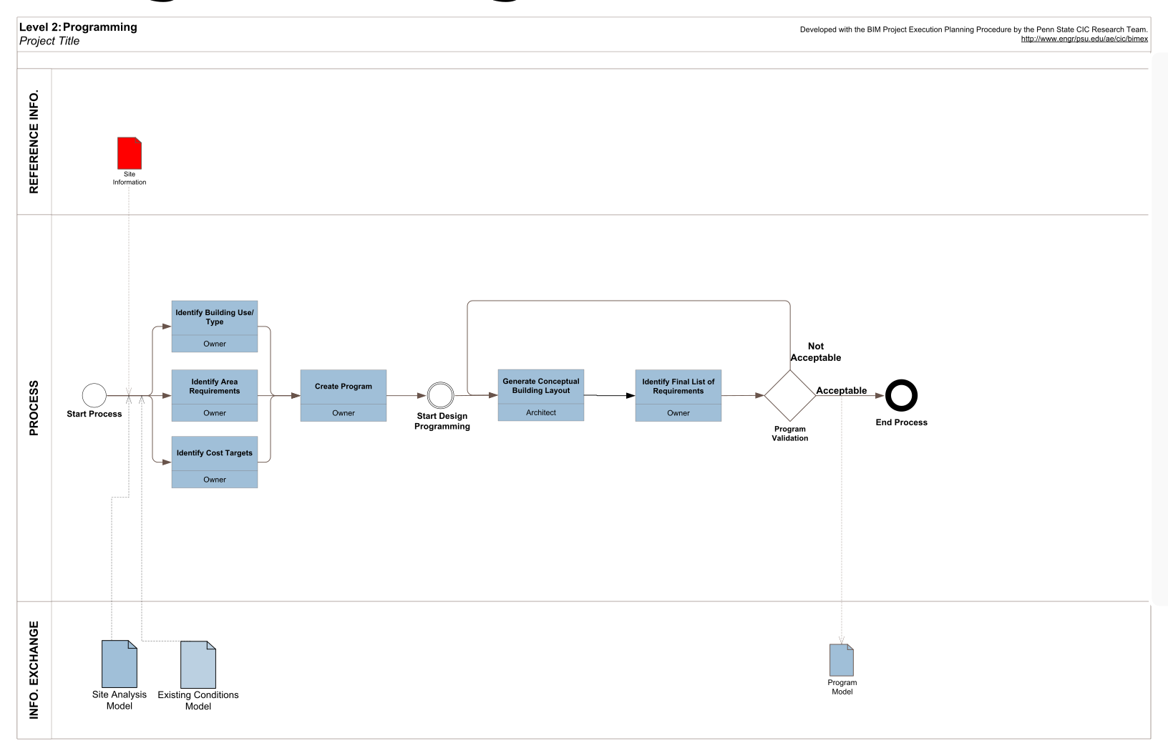

Output

Description

A process in which a spatial program is used to efficiently and accurately assess design performance in regard to spatial requirements. The developed BIM model allows the project team to analyze space and understand the complexity of space standards and regulations. Critical decisions are made in this phase of design and bring the most value to the project when needs and options are discussed with the client and the best approach is analyzed.

Potential Value

* Efficient and accurate assessment of design performance in regard to spatial requirements by the owner.

Resources Required

* Design Authoring Software
* Programming software

Team Competencies Required

* Ability to manipulate, navigate, and review a 3D model

References for Additional Information

General Services Administration (GSA) BIM Guide 02. Spatial Program Validation. Available at www.gsa.gov/bim.

Potential Output Information

* Program in Digital Format
* Reports of Design Conformance with Program

Source:  BIM Project Execution Planning Guide, Ver. 2.2 with minor revisions.

## 05: Site Analysis

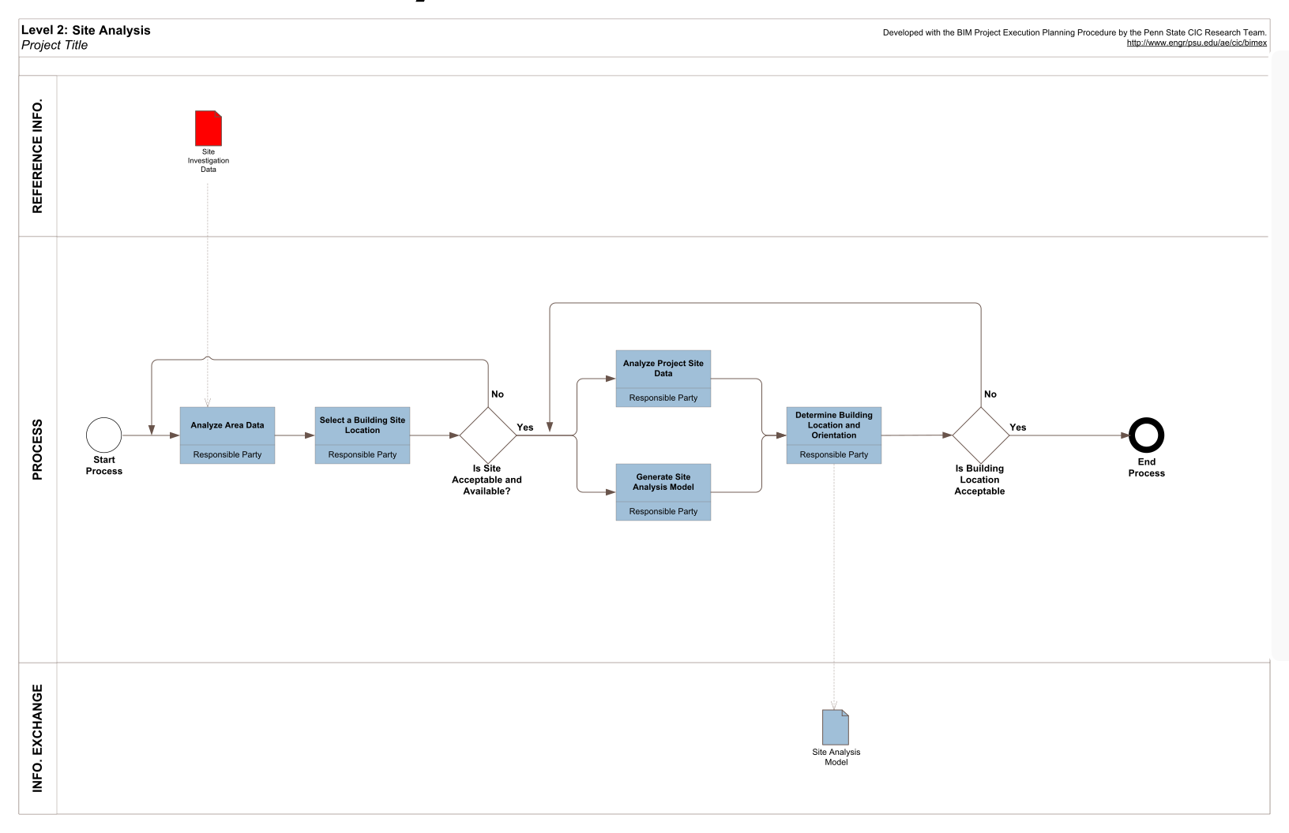

Output

Description

Using BIM and/or Geographic Information System (GIS) to evaluate sites within a given area to determine the optimal site location for a future project. The site data collected is used to first select the site and then position the building and infrastructure based on other criteria.

Potential Value

* Use calculated decision making to determine if potential sites meet the required criteria according to project requirements, technical factors, and financial factors
* Decrease costs of utility demand and demolition
* Increase energy efficiency
* Minimize risk of hazardous material
* Maximize return on investment

Resources Required

* GIS and/or BIM Authoring software
* 3D Model manipulation

Team Competencies Required

* Ability to manipulate, navigate, and review a 3D model
* Knowledge and understanding of local authority's system (GIS, database information)

References for Additional Information

The Site Selection Guide. US General Services Administration (GSA) Public Building Service.

Optimal Site Selection for Military Land Management, R.M. Wallace, ASCE Conf. Proc. 138, 159 (2004).Â  DOI: 10. 1061/40737(2004)159.

Farnsworth, Stephen J. “Site Selection Perspective.” Prospecting Sites. June 1995, 29-31.

WPBG Sustainable Committee.Â  Optimizing Site Potential.

Suermann P.C. Leveraging GIS Tools in Defense and Response at the U.S. Air Force Academy. ASCE Conf. Proc. 179, 82 (2005) DOI: 10. 1061/40794(179)82.

GIS - Based Engineering Management Service Functions: Taking GIS Beyond Mapping for Municipal Governments.

Potential Output Information

* Site analysis report

Source:  BIM Project Execution Planning Guide, Ver. 2.2 with minor revisions.

## 06: Design Authoring

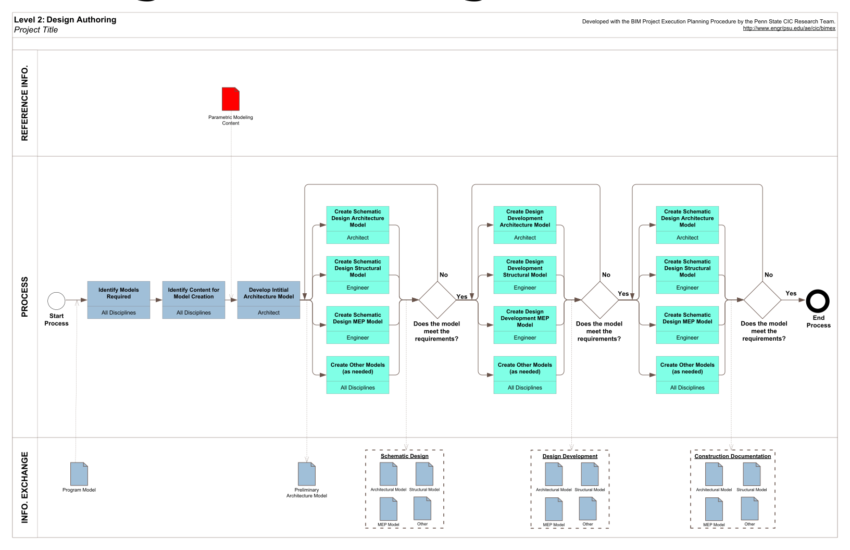

Output

Output

Output

Output

Description

A process in which 3D software is used to develop a Building Information Model based on criteria that is important to the translation of the building's design. Authoring tools create models while audit and analysis tools study or add to the richness of information in a model. Most of audit and analysis tools can be used for Design Review and Engineering AnalysisÂ BIM Uses. Design authoring tools are a first step towards BIM and the key is connecting the 3D model with a powerful database of properties, quantities, means and methods, costs and schedules.

Potential Value

* Transparency of design for all stakeholders
* Better control and quality control of design, cost and schedule
* Powerful design visualization
* True collaboration between project stakeholders and BIM users
* Improved quality control and assurance

Resources Required

* Design Authoring Software

Team Competencies Required

* Ability to manipulate, navigate, and review a 3D model
* Knowledge of construction means and methods
* Design and construction experience

References for Additional Information

Tardif, M. (2008). BIM: Reaching Forward, Reaching Back. AIArchitect This Week. Face of the AIA . AIArchitect

Potential Output Information

* Design model

Source:  BIM Project Execution Planning Guide, Ver. 2.2 with minor revisions.

## 07: Design Review

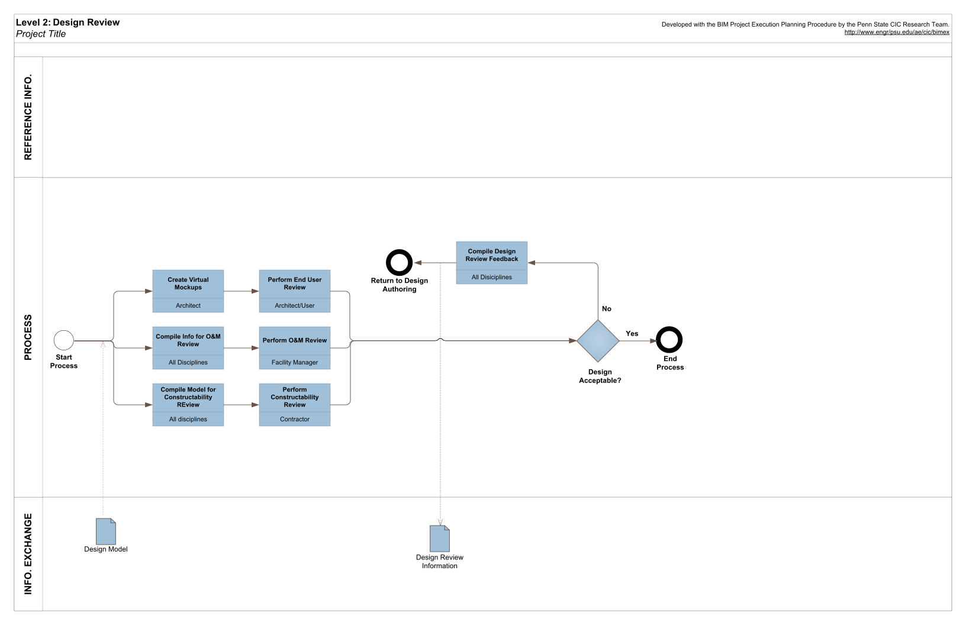

Output

Description

A process in which stakeholders view a 3D model and provide their feedbacks to validate multiple design aspects. These aspects include evaluating meeting the program, previewing space aesthetics and layout in a virtual environment, and setting criteria such as layout, sightlines, lighting, security, ergonomics, acoustics, textures and colors, etc. This BIM use can be done by using computer software only or with special virtual mock-up facilities, such as CAVE (Computer Assisted Virtual Environment) and immersive lab. Virtual mock-ups can be performed at various levels of detail depending on project needs. An example of this is to create a highly detailed model of a small portion of the building, such as a facade to quickly analyze design alternatives and solve design and constructability issues.

 Potential Value

* Eliminate costly and timely traditional construction mock-ups
* Different design options and alternatives may be easily modeled and changed in real-time during design review base on end users and/or owner feedbacks
* Create shorter and more efficient design and design review process
* Evaluate effectiveness of design in meeting building program criteria and owner's needs
* Enhance the health, safety and welfare performance of their projects (For instance, BIM can be used to analyze and compare fire-rated egress enclosures, automatic sprinkler system designs, and alternate stair layouts)
* Easily communicate the design to the owner, construction team and end users
* Get instant feedbacks on meeting program requirements, owner's needs and building or space aesthetics
* Greatly increase coordination and communication between different parties. More likely to generate better decisions for design

Resources Required

* Design Review Software
* Interactive review space
* Hardware which is capable of processing potential large model files

Team Competencies Required

* Ability to manipulate, navigate, and review a 3D model
* Ability to model photo realistically including textures, colors and finishes and easily navigable by using different software or plug-ins
* Strong sense of coordination. Understanding roles and responsibilities of team members
* Strong understanding of how building/facility systems integrate with one another

References for Additional Information

Dunston, Phillip S., Arns, Laura L., and McGlothin, James D. (2007). “An Immersive Virtual Reality Mock-Up for Design Review of Hospital Patient Rooms,” 7th International Conference on Construction Applications of Virtual Reality, University Park, Pennsylvania, October 22-23.

Majumdar, Tulika, Fischer, Martin A., and Schwegler, Benedict R. (2006). “Conceptual Design Review with a Virtual Reality Mock-Up Model,” Building on IT: Joint International Conference on Computing and Decision Making in Civil and Building Engineering, Hugues Rivard, Edmond Miresco, and Hani Melham, editors, Montreal, Canada, June 14-16, 2902-2911.

Maldovan, Kurt D., Messner, John I., and Faddoul, Mera (2006). “Framework for Reviewing Mockups in an Immersive Environment,” CONVR 2006:6th International Conference on Construction Applications of Virtual Reality, R. Raymond issa, editor, Orlando, Florida, August 3-4, on CD.

Bassanino, May Wu, Kuo-Cheng Yao, Jialiang Khosrowshahi, Farzad Fernando, Terrence Skjaerbaek, Jens. (2010). “The Impact of Immersive Virtual Reality on Visualisation for a Design Review in Construction,” 14th International Conference Information Visualisation.

Xiangyu Wang and Phillip S. Dunston. (2005). “System Evaluation of a Mixed Reality-Based Collaborative Prototype for Mechanical Design Review Collaboration,” Computing in Civil Engineering, Volume 21, issue 6, page: 393-401.

Shiratuddin, M.F and Thabet, WalidA. (2003). “Framework for a Collaborative Design Review System Utilizing the Unreal Tournament (UT) Game Development Tool,” CIB REPORT.

NavisWorks (2007), “Integrated BIM and Design Review for Safer, Better Buildings,” (http://www.eua.com/pdf/resources/integrated_project/Integrated_BIM-safer_better_buildings.pdf).

Potential Output Information

* Model with design review feedback embedded
* Design review report with design feedback

Source:  BIM Project Execution Planning Guide, Ver. 2.2 with minor revisions.

# Use Cases : Design

## 08: Structural Analysis

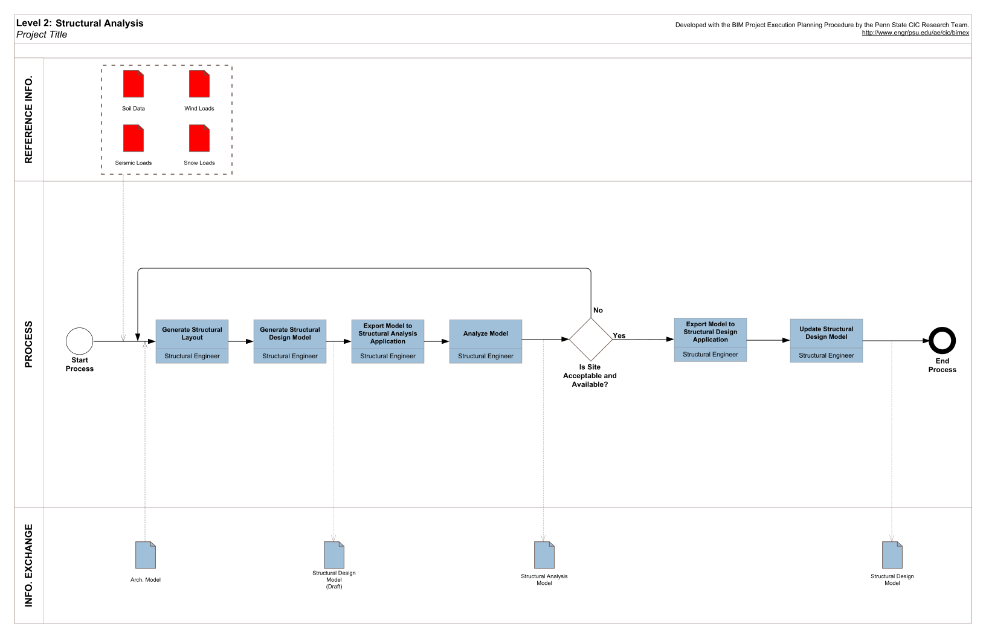

Output 1

Output 2

Description

A process in which analytical modeling software utilizes the BIM design authoring model so to determine the behavior of a given structural system. With the modeling minimum required standards for structural design and analysis are used for optimization. Based on this analysis further development and refinement of the structural design takes place to create effective, efficient, and constructible structural systems. The development of this information is the basis for what will be passed onto the digital fabrication and construction system design phases.

This BIM Use does not need to be implemented from the beginning of the design to be beneficial. Often structural analysis is implemented at the connection design level to make fabrication quicker, more efficient and for better coordination during construction. Another application is that this relates and ties into is construction system design, examples include but not limited to: erection design, construction means and methods, and rigging. The application of this analysis tool allows for performance simulations that can significantly improve the design, performance, and safety of the facility over its lifecycle.

Potential Value

* Save time and cost on creating extra models
* Easier transition BIM authoring tools allowing new firms implementing this use model
* Improve specialized expertise and services offered by the design firm
* Achieve optimum efficient design solutions by applying various rigorous analyses
* Faster return on investment with applying audit and analysis tools for engineering analyses
* Improve the quality of the design analyses
* Reduce the cycle time of the design analyses

Resources Required

* Design Authoring Tools
* Structural Engineering analysis tools and software
* Design standards and codes
* Adequate hardware for running software

Team Competencies Required

Ability to create, manipulate, navigate, and review a 3D Structural Model

Ability to assess a model through engineering analysis tools

Knowledge of constructability methods

Knowledge of analytical modeling techniques

Knowledge of structural behavior and design

Design experience

Integration expertise pertaining to building systems as a whole

Experience in structural sequencing methods

References for Additional Information

Ikerd, Will (2007) “The Importance of BIM in Structural Engineering: The greatest change in over a century” Structure Magazine, October, 37-40

Burt, Bruce (2009) “BIM Interoperability: the Promise and the Reality” Structure Magazine, December, 19-21

Faraone, Thomas, et al. (2009) “BIM Resources for the AEC Community” Structure Magazine, March, 32-33

Eastman et al (2010) “Exchange Model and Exchange Object Concepts for Implementation of National BIM Standards”, Journal of Computing in Civil Engineering, (January/February): 25-34. ASCE.

Barak et al (2009) “Unique Requirements of Building Information Modeling for CIP Reinforced Concrete”, Journal of Computing in Civil Engineering, (March/April): 64-74. ASCE.

Potential Output Information

* Structural design model
* Structural analysis report
* Information exchange for structural elements to architectural design

Source:  BIM Project Execution Planning Guide, Ver. 2.2 with minor revisions.

## 09: Lighting Analysis

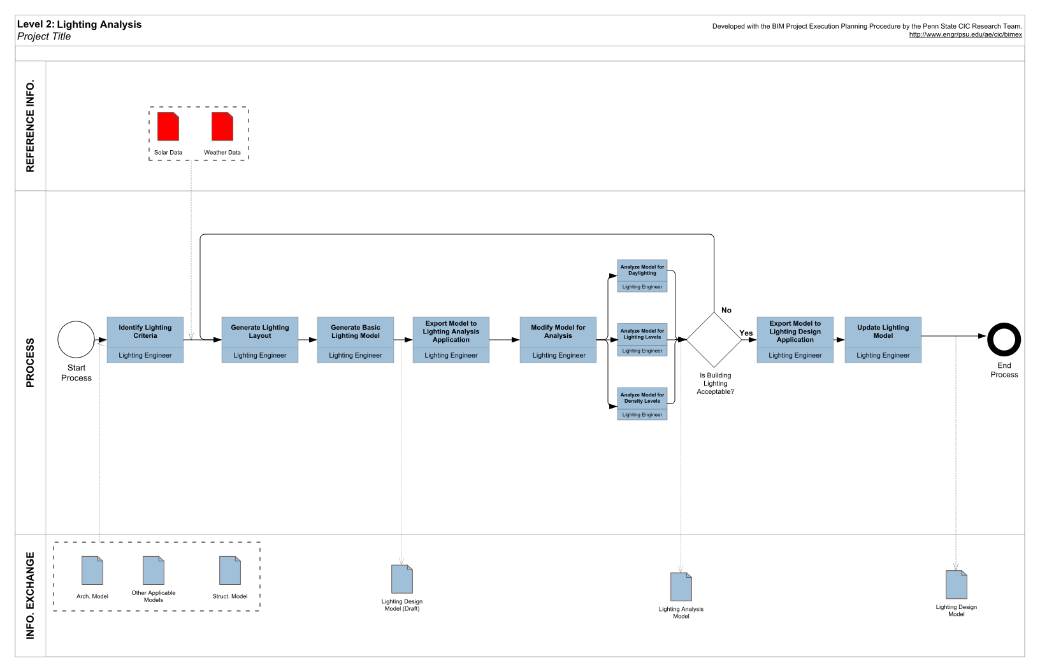

Output 1

Output 2

Description

A process in which analytical modeling software utilizes the BIM design authoring model so to determine the behavior of a given lighting system. This can also include artificial (indoor and outdoor) and natural (daylighting and solar shading) lighting. Based on this analysis further development and refinement of the lighting design takes place to create effective, efficient, and constructible lighting systems. The application of this analysis tool allows for performance simulations that can significantly improve the design, and performance of the facility's lighting over its lifecycle.

## 10: Energy Analysis

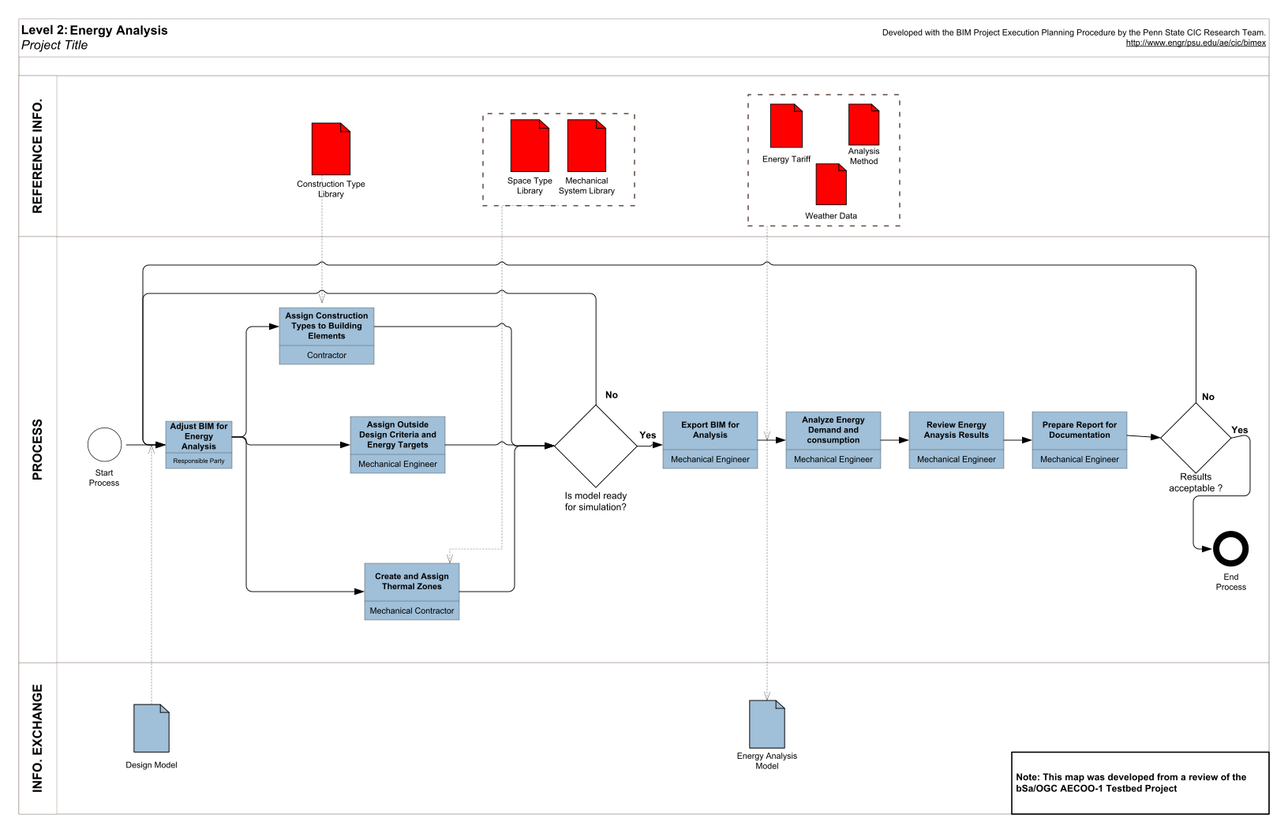

Output

Description

A process in the design phase which one or more building energy simulation programs use a properly adjusted BIM model to conduct energy assessments for the current building design. The core goal of this BIM use is to inspect building energy standard compatibility and seek opportunities to optimize proposed design to reduce structure's life-cycle costs.

Potential Value

* Save time and costs by obtaining building and system information automatically from BIM model instead of inputting data manually
* Improve building energy prediction accuracy by auto-determining building information such as geometries, volumes precisely from BIM model
* Help with building energy code verification
* Optimize building design for better building performance efficiency and reduce building life-cycle cost

Resources Required

* Building Energy Simulation and Analysis Software(s)
* Well-adjusted Building 3D-BIM Model
* Detailed Local Weather Data
* National/Local Building Energy Standards (e.g. ASHRAE Standard 90.1)

Team Competencies Required

* Knowledge of basic building energy systems
* Knowledge of compatible building energy standard
* Knowledge and experience of building system design
* Ability to manipulate, navigate, and review a 3D Model
* Ability to assess a model through engineering analysis tools

References for Additional Information

General Services Administration (GSA) (2015). “BIM Guide 05 - Energy Performance.”  Version 2.1. Available at <http://www.gsa.gov/bim>.

ASHRAE. 2009. ASHRE Handbook-Fundamentals. Atlanta. American Society of Heating, Refrigerating and Air-Conditioning Engineers, Inc.

Bazjanac. V. (2008). IFC BIM-Based Methodology for Semi-Automated Building Energy Performance Simulation. Proceedings of CIB-W78 25th International Conferenceon Information Technology in Construction.

Stumpf. A., Kim. H., Jenicek. E. (2009). Early Design Energy Analysis Using BIMS (Building Information Models). 2009 Construction Research Congress. ASCE.

Cho. Y. K., Alaskar. S., and Bode.T.A. (2010). BIM-Integrated Sustainable Material and Renewable Energy Simulation. 2010 Construction Research Congress. ASCE

Potential Output Information

• Energy model

• Predicted energy use with variation based upon design alternatives

Source:  BIM Project Execution Planning Guide, Ver. 2.2 with minor revisions.

## 11: Sustainability Analysis

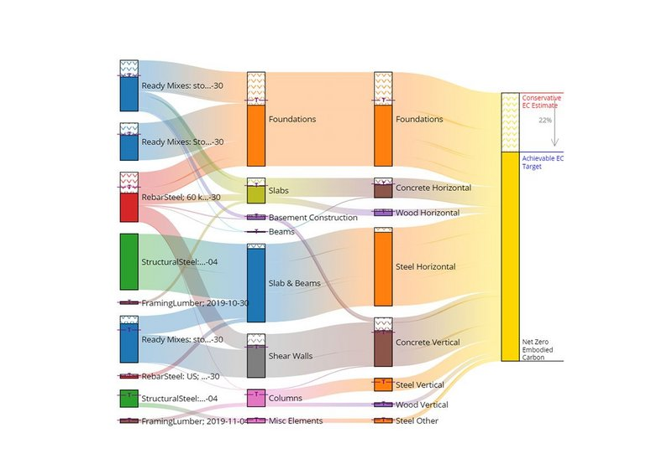

Description

A process to evaluate and track the sustainability performance of a facility by using a sustainability metric system, e.g., LEED, Green Globes, etc. This process should occur during all stages of a facilities life including planning, design, construction, and operation. Applying sustainable features to a project in the planning and early design phases is more effective (ability to impact design) and efficient (cost and schedule of decisions). This comprehensive process requires more disciplines to interact earlier by providing valuable insights. This integration may require contractual integration in planning phase. In addition to achieving sustainable goals, having LEED approval process adds certain calculations, documentations, and verifications. Energy simulations, calculations, and documentations can be performed within an integrative environment when responsibilities are well defined and clearly shared.

Potential Value

* Facilitates interaction, collaboration and coordination of team members early in the project process are considered to be favorable to sustainable projects.
* Enables early and reliable evaluation of design alternatives.
* Availability of critical information early helps problem resolution efficiently in terms of cost premium and schedule conflicts.
* Shortens the actual design process by the help of early facilitated design decisions. Shorter design process is cost effective and provides more time for other projects.
* Leads to delivery better project quality.
* Reduces documentation load after design and accelerates certification because concurrently prepared calculations can be used for verification.
* Reduces operational costs of the facility due to the energy performance of the project. It optimized building performance via improved energy management.
* Increases the emphasis on environmentally friendly and sustainable design.
* Assists project team with potential future revisions throughout the life cycle.

Resources Required

* Design authoring software

Team Competencies Required

* Ability to create and review 3D Model
* Knowledge of up-to-date LEED Credit Information
* Ability to organize and manage the database

References for Additional Information

Krygiel, E., and Brad, N. , 2008, “Green BIM: Successful Sustainable Design with Building Information Modeling,” San Francisco.

McGraw Hill Construction, 2010, “Green BIM-How Building Information Modeling Is Contributing to Green Design and Construction,” Smart Market Report, McGraw Hill Construction.

Balfour Beatty Construction, 2010, “Sustainability and Engineering Guide Version 2.0,” Balfour Beatty Construction.

Output

Potential Output Information

Sustainability evaluation status and report

Source:  BIM Project Execution Planning Guide, Ver. 2.2 with minor revisions.

## 12: Code Validation

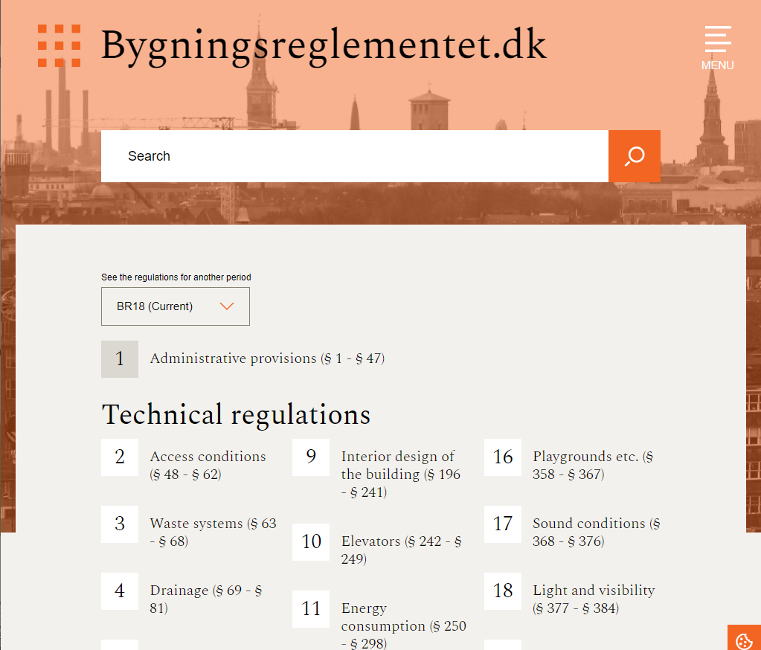

Description

A process in which code validation software is utilized to check the model parameters against project specific codes. Code validation is currently in its infant stage of development within the U.S. and is not in widespread use. However, as model checking tools continue to develop, code compliance software with more codes, code validation should become more prevalent within the design industry.

Potential Value

* Validate that building design is in compliance with specific codes, e.g. IBC International Building Code, ADA Americans with Disabilities Act guidelines and other project related codes using the 3D BIM model.
* Code validation done early in design reduces the chance of code design errors, omissions or oversights that would be time consuming and more expensive to correct later in design or construction.
* Code validation done automatically while design progresses gives continuous feedback on code compliance .Â
* Reduced turnaround time for 3D BIM model review by local code officials or reduced time that needs to be spent meeting with code commissioners, visiting the site, etc. or fixing code violations during punch list or closeout phase.
* Saves time on multiple checking for code compliance and allows for a more efficient design process since mistakes cost time and money.

Resources Required

* Local codes
* Model checking software
* 3D Model manipulation

Team Competencies Required

* Ability to use BIM authoring tool for design and model checking tool for design review
* Ability to use code validation software and previous knowledge and experience with checking codes is needed.

References for Additional Information

Automated Circulation Validation using BIM.  GSA.  1-22.

Eastman, C., Liston, K., Sacks, R. and Teicholz, P. BIM Handbook: A Guide to Building Information Modeling for Owners, Managers, Designers, Engineers and Contractors.”  New York, NY, Wiley, 2008.

Output

Potential Output Information

* Report of Code Violations

Source:  BIM Project Execution Planning Guide, Ver. 2.2 with minor revisions.

## 13: Design Coordination

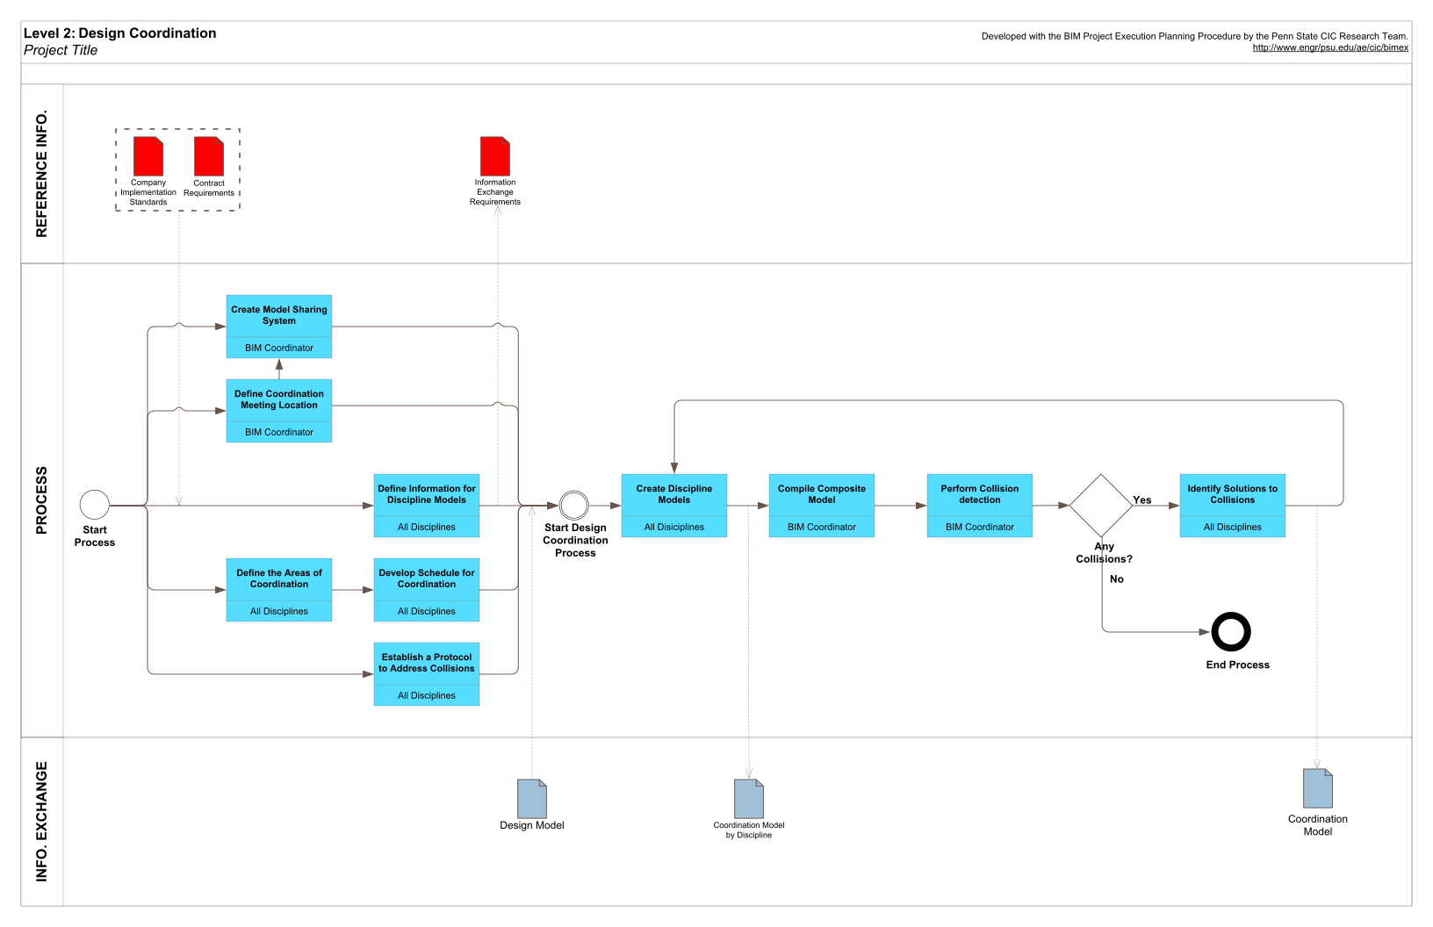

Output 2

Output 1

Description

A process in which 3D coordination software is used to determine identify 3D geometric conflicts by comparing 3D models of building systems. The goal of 3D coordination is to eliminate field conflicts and coordination issues prior to installation.

Potential Value

* Coordinate building project through a model
* Reduce and eliminate field conflicts; which reduces RFI's significantly compared to other methods
* Visualize construction
* Increase productivity
* Reduced construction cost; potentially less cost growth (i.e. less change orders)
* Decrease construction time
* Increase productivity on site
* More accurate as built drawings

Resources Required

* Design Authoring Software
* Model Review Software

Team Competencies Required

* Ability to deal with people and project challenges
* Ability to manipulate, navigate, and review a 3D model
* Knowledge of BIM model applications for facility updates
* Knowledge of building systems

References for Additional Information

Staub-French S and Khanzode A (2007) "3D and 4D Modeling for design and construction coordination: issues and lessons learned" ITcon Vol. 12, pg. 381-407, http://www.itcon.org/2007/26

Khanzode A, Fischer M, Reed D (2008) "Benefits and lessons learned of implementing building virtual design and construction (VDC) technologies for coordination of mechanical, electrical, and plumbing (MEP) systems on a large healthcare project", ITcon Vol. 13, Special Issue Case studies of BIM use , pg. 324-342, <http://www.itcon.org/2008/22>

Potential Output Information

* 3D coordination report identifying 3D coordination issues

Source:  BIM Project Execution Planning Guide, Ver. 2.2 with minor revisions.

# Use Cases : Build

You can see the McKinsey report in General > Reports

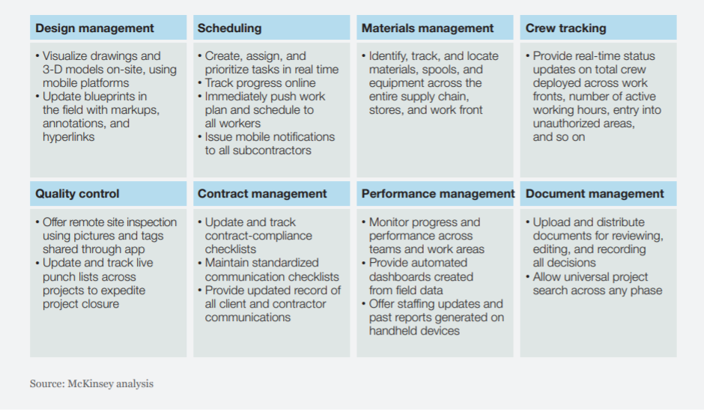

## 14: Site Utilization Planning

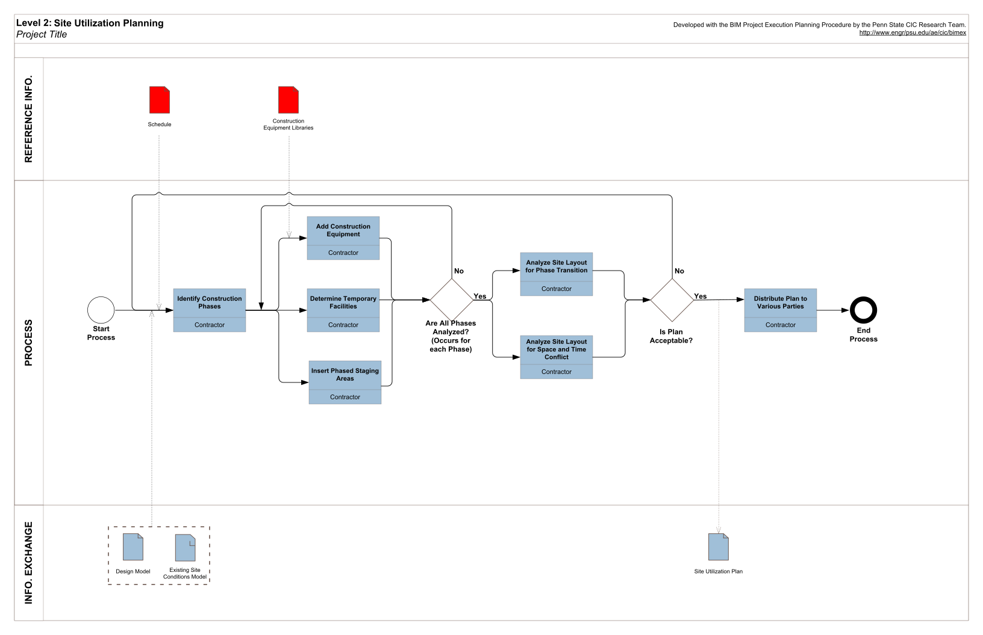

Output

Description

Using models to graphically represent both permanent and temporary facilities on site during multiple phases of the construction process. It may also be linked with the construction activity schedule to convey space and sequencing requirements.  Additional information incorporated into the model can include labor resources, materials with associated deliveries, and equipment location. Because the 3D model components can be directly linked to the schedule, site management functions such as visualized planning, short-term re-planning, and resource analysis can be analyzed over different spatial and temporal data.

Potential Value

* Efficiently generate site usage layout for temporary facilities, assembly areas, and material deliveries for all phases of construction
* Quickly identify potential and critical space and time conflicts
* Accurately evaluate site layout for safety concerns
* Select a feasible construction scheme
* Effectively communicate construction sequence and layout to all interested parties
* Easily update site organization and space usage as construction progresses
* Minimize the amount of time spent performing site utilization planning

Resources Required

* Design authoring software
* Scheduling software
* 4D model integration software
* Detailed existing conditions site plan

Team Competencies Required

* Ability to create, manipulate, navigate, and review a 3D Model
* Ability to manipulate and assess construction schedule with a 3D model
* Ability to understand typical construction methods
* Ability to translate field knowledge to a technological process

•

References for Additional Information

Chau, K.W.; M. Anson, and J.P. Zhang. (2004) “Four-Dimensional Visualization of Construction Scheduling and Site Utilization.” Journal of Construction Engineering and Management. 598-606. ASCE. 5 September.  http://cedb.asce.org/cgi/WWWdisplay.cgi?0410956

Dawood, N. et al. (2005) “The Virtual Construction Site (VIRCON) Tools: An Industrial Evaluation.” ITcon. Vol. 10 43-54. http://www.itcon.org/cgi-bin/works/Show?2005_5

Heesom, D. and Mahdjoubi, L.. (2004) “Trends of 4D CAD Applications for Construction Planning.” Construction Management and Economics. 22 171-182.. http://www.tamu.edu/classes/choudhury/articles/1.pdf

J.P. Zhang, M. Anson and Q. Wang. (2000) “A New 4D Management Approach to Construction Planning and Site Space Utilization.” Proceedings of the Eighth International Conference on Computing in Civil and Building Engineering 279, 3 ASCE. http://dx.doi.org/10.1061/40513(279)3.

J. H. Kang, S. D. Anderson, M. J. Clayton. (2007) “Empirical Study on the Merit of Web-Based 4D Visualization in Collaborative Construction Planning and Scheduling.” J. Constr. Engrg. and Mgmt. Volume 133, Issue 6, pp. 447-461 ASCE.  http://dx.doi.org/10.1061/(ASCE)0733-9364(2007)133:6(447)

Timo Hartmann, Ju Gao and Martin Fischer. (2008) "Areas of Application for 3D and 4D Models." Journal of Construction Engineering and Management (135: 10): 776-785.

Ting Huang, C.W. Kong, H.L. Guo, Andrew Baldwin, Heng Li. (2007) "A Virtual Prototyping System for Simulating Construction Processes." Automation in Construction, 16:5, 576-585, http://www.sciencedirect.com/science/article/B6V20-4MFJT9J-1/2/45a7645cc1a6836c45317a012fbc181a

Lorenzo Beltrani’s Thesis (2020) [Auto Generation of Optimised Construction Site Layout](https://findit.dtu.dk/en/catalog/2597546931?single_revert=%2Fen%2Fcatalog%3Fq%3Dlorenzo%2Bbeltrani%26show_single%3Doff%26utf8%3D%25E2%259C%2593)

Potential Output Information

* 2D or 3D site utilization plans

Source:  BIM Project Execution Planning Guide, Ver. 2.2 with minor revisions.

## 15: Construction System Design

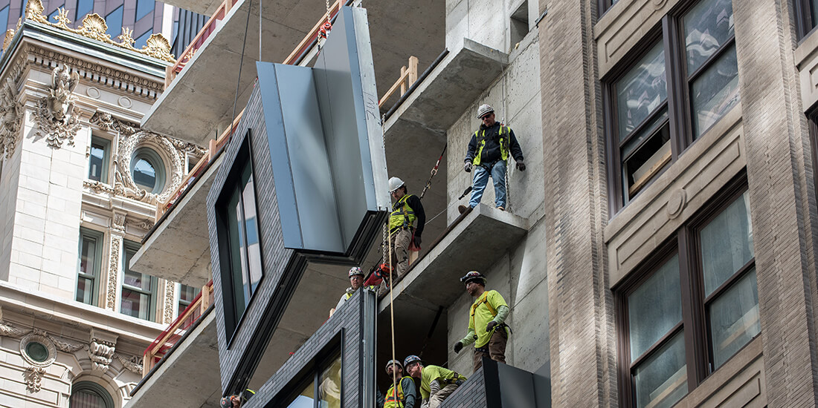

Description

Using 3D System Design Software to design and analyze the construction of a complex building system (e.g., form work, glazing, support of excavation, etc.) to increase planning.

Potential Value

* Increase constructability of a complex building system
* Increase construction productivity
* Increase safety awareness of a complex building system
* Decrease language barriers

Resources Required

* 3D System design software

Team Competencies Required

* Ability to manipulate, navigate, and review 3D model
* Ability to make appropriate construction decisions using a 3D System Design Software
* Knowledge of typical and appropriate construction practices for each component

References for Additional Information

* Leventhal, L. “Delivering Instruction for Inherently-3D Construction Tasks: Lessons and Questions for Universal Accessibility”.  Workshop on Universal Accessibility of Ubiquitous Computing: Providing for the elderly.
* Khemlano (2007).  AECbytes: Building the Future (Oct. 18).

Output

Potential Output Information

* Detailed 3D model of construction system
* Drawings for component fabrication
* Model to support digital fabrication of elements

Source:  BIM Project Execution Planning Guide, Ver. 2.2 with minor revisions.

## 16: Digital Fabrication

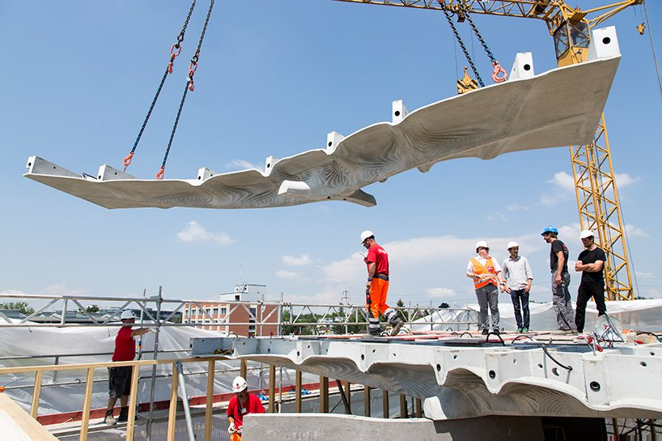

Description

A process that uses digitized information to facilitate the fabrication of construction materials or assemblies. Some uses of digital fabrication can be seen in sheet metal fabrication, structural steel fabrication, pipe cutting, prototyping for design intent reviews etc. It assists in ensuring that the downstream phase of manufacturing has minimum ambiguities and enough information to fabricate with minimal waste. An information model could also be used with suitable technologies to assemble the fabricated parts into the final assembly.

Potential Value

* Ensuring quality of information
* Minimize tolerances through machine fabrication
* Increase fabrication productivity and safety
* Reduce lead time
* Adapt late changes in design
* Reduced dependency on 2D paper drawings

Resources Required

* Design Authoring Software
* Machine readable data for fabrication
* Fabrication methods

Team Competencies Required

* Ability to understand and create fabrication models
* Ability to manipulate, navigate, and review a 3D model
* Ability to extract digital information for fabrication from 3D models
* Ability to manufacture building components using digital information
* Ability to understand typical fabrication methods

References for Additional Information

Eastman, C. (2008) "BIM HANDBOOK A Guide to Building Information Modeling for Owners, Managers, Designers, Engineers and Contractors."

Papanikolaou, D. (2008). "Digital Fabrication Production System Theory: towards an integrated environment for design and production of assemblies." Cuba, 484-488.

Reifschneider, M. (2009). "Managing the quality if structural steel Building Information Modeling."

Rundell, R. (2008). "BIM and Digital Fabrication (1-2-3 Revit Tutorial)."

Sass, L. (2005). "A production system for design and construction with digital fabrication." MIT.

Seely, J. C. (2004). "Digital Fabrication in the Architectural Design Process." Master Thesis, Massachusetts Institute of Technology.

Output

Potential Output Information

* Fabrication models
* Physical fabricated elements

Source:  BIM Project Execution Planning Guide, Ver. 2.2 with minor revisions.

## 17: 3D Control and Planning

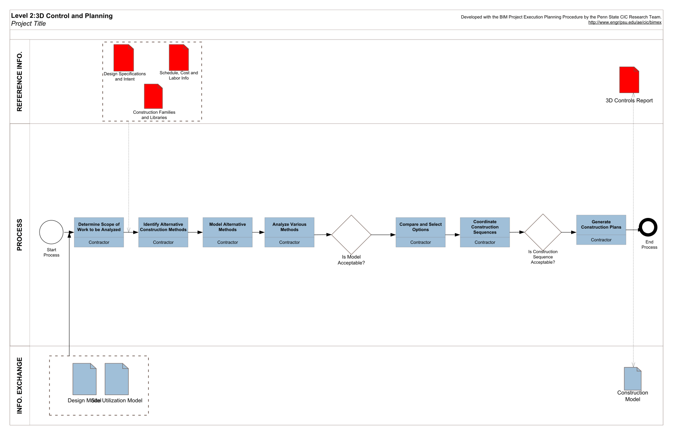

Output

Description

A process that utilizes an information model to layout facility assemblies or automate control of equipment's movement and location. The information model is used to create detailed control points aid in assembly layout. An example of this is layout of walls using a total station with points preloaded and/or using GPS coordinates to determine if proper excavation depth is reached.

Potential Value

* Decrease layout errors by linking model with real world coordinates
* Increase efficiency and productivity by decreasing time spent surveying in the field
* Reduce rework because control points are received directly from the model
* Decrease / eliminate language barriers

Resources Required

* Machinery with GPS capabilities
* Digital Layout Equipment
* Model Transition Software (what software takes model and converts it to usable information).

Team Competencies Required

* Ability to create, manipulate, navigate and review 3D model
* Ability to use model data for layout and equipment control

References for Additional Information

Garrett, R. E. (2007). PennDOT About to Embrace GPS Technology. Retrieved 2010, from gradingandexcavation.com: http://www.gradingandexcavation.com/january-february-2007/penndot-gps-technology.aspx>.

Strafaci, A. (2008). What Does BIM Mean for Civil Engineers? Retrieved 2010, from cenews.com: http://images.autodesk.com/emea_s_main/files/what_does_bim_mean_for_civil_engineers_ce_news_1008.pdf

TEKLA International. (2008). Tekla Corporation and Trimble to Improve Construction Field Layout Using Building Information Modeling.

Potential Output Information

* Physical layout onsite
* Digital information for surveying equipment

Source:  BIM Project Execution Planning Guide, Ver. 2.2 with minor revisions.

# Use Cases : Use / Occupation

Description of services 2018

## 9.58 ‘As built’

‘As built’ services are provided to bring the project documentation to a level at which the documents and the currently completed project are consistent with one another to the extent specified in addition to the update required to obtain regulatory approval and an operating permit within the consultant’s field of responsibility. The level of such consistency may be agreed in accordance with the Danish Association of Architectural Firms’ and the Danish Association of Consulting Engineers’ description of services ‘As built’.

## 18: Record Modelling

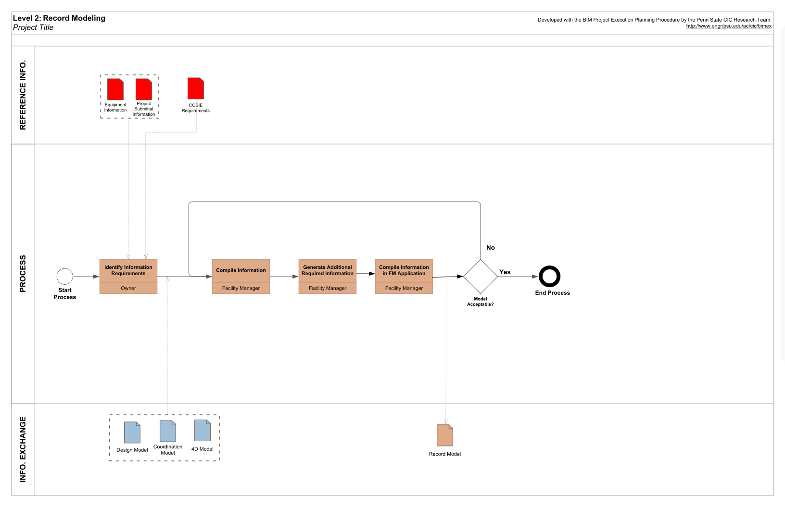

Output

Description

Record Modeling is the process used to depict an accurate representation of the physical conditions, environment, and assets of a facility. The record model should, at a minimum, contain information relating to the main architectural, structural, and MEP elements. It is the culmination of all the BIM Modeling throughout the project, including linking Operation, Maintenance, and Asset data to the As-Built model (created from the Design, Construction, 4D Coordination Models, and Subcontractor Fabrication Models) to deliver a record model to the owner or facility manager. Additional information including equipment and space planning systems may be necessary if the owner intends to utilize the information in the future.

Potential Value

* Aid in future modeling and 3D design coordination for renovation Improve documentation of environment for future uses, e.g., renovation or historical documentation
* Aid in the permitting process (e.g. continuous change vs. specified code.)
* Minimize facility turnover dispute (e.g. link to contract with historical data highlights expectations and comparisons drawn to final product.)
* Ability for embedding future data based upon renovation or equipment replacement
* Provide owner with accurate model of building, equipment, and spaces within a building to create possible synergies with other BIM Uses
* Minimize building turnover information and required storage space for this information
* Better accommodate owner's needs and wants to help foster a stronger relationship and promote repeat business
* Easily assess client requirement data such as room areas or environmental performance to as-designed, as-built or as-performing data.

Resources Required

* under development

Team Competencies Required

* Ability to manipulate, navigate, and review 3D model
* Ability to use BIM modeling application for building updates
* Ability to thoroughly understand facility operations processes to ensure correct input of information
* Ability to effectively communicate between the design, construction, and facilities management teams

References for Additional Information

Brown, J. L. (September 2009). Wisconsin Bets on BIM. Civil Engineering , 40-41.

CRC for Construction Innovation. Adopting BIM for Facilities Management - Solutions for Managing the Syndey Opera House.

Gregerson, J. (December 2009). For Owners, BIM Has Vim. Buildings , 26.

Knight, D., Roth, S., & Rosen, S. (June 2010). Using BIM in HVAC Design. ASHRAE Journal , 24-34.

Madsen, J. J. (July 2008). Build Smarter, Faster, and Cheaper with BIM. Buildings , 94-96.

McKew, H. (July 2009). Owners, Please Demand More From Your IPD Team. Engineered Systems , 50.

Woo, J., Wilsmann, J., & Kang, D. (2010). Use of As-Built Building Information Modeling. Construction Research Congress 2010 , 538-548.

Potential Output Information

* Model including Facility Management Information
* Facility Asset List for Input into Facility Management System

Source:  BIM Project Execution Planning Guide, Ver. 2.2 with minor revisions.

## 19: Maintenance Scheduling

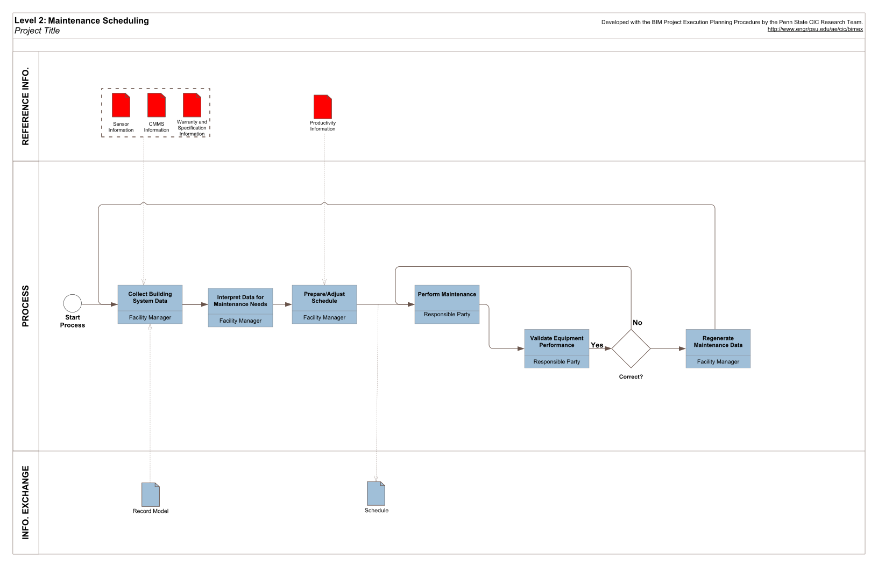

Output

Description

A process in which the functionality of the building structure (walls, floors, roof, etc) and equipment serving the building (mechanical, electrical, plumbing, etc) are maintained over the operational life of a facility. A successful maintenance program will improve building performance, reduce repairs, and reduce overall maintenance costs.

Potential Value

* Plan maintenance activities proactively and appropriately allocate maintenance staff
* Track maintenance history
* Reduce corrective maintenance and emergency maintenance repairs
* Increase productivity of maintenance staff because the physical location of equipment/system is clearly understood
* Evaluate different maintenance approaches based on cost
* Allow facility managers to justify the need and cost of establishing a reliability centered maintenance program

Resources Required

* Design review software to view Record ModelÂ and components
* Building Automation System (BAS) linked to Record Model
* Computerized Maintenance Management System (CMMS) linked to Record Model
* User-Friendly Dashboard Interface linked to Record Model to provide building performance information and/or other information to educate building users

Team Competencies Required

* Ability to understand and manipulate CMMSÂ and building control systems with Record Model
* Ability to understand typical equipment operation and maintenance practices
* Ability to manipulate, navigate, and review a 3D Model

References for Additional Information

Campbell, D.A. (2007). BIM - Web Applications for AEC, Web 3D Symposium.

Fallon, K. (2008). “Interoperability: Critical to Achieving BIM Benefits”. AIA Edges Website: Singh, H.; W.H. Dunn (2008).Â  Integrating Facilities Stovepipes for Total Asset ManagementÂ (TAM). Journal of Building Information Modeling, Spring 2008. http://www.aia.ord/nwsltr_tap.cfm?pagename=tap_a_0704_interop

ASHRAE (2003). HVAC design Manual for Hospitals and Clinics. Atlanta, GA. (2004). Federal energy Management Program.Â O&M Best Practices: A Guide to Achieving Operational Efficiency, Release 2.0.Â  July 2004.Â  www1.eere.energy.gov/femp/pds.OM_5.pdf

Piotrowski, J. (2001).Â Pro-Active Maintenance for Pumps. Archives, February, Pump-Zone.com

Potential Output Information

* under development

Source:  BIM Project Execution Planning Guide, Ver. 2.2 with minor revisions.

## 20: Building System Analysis

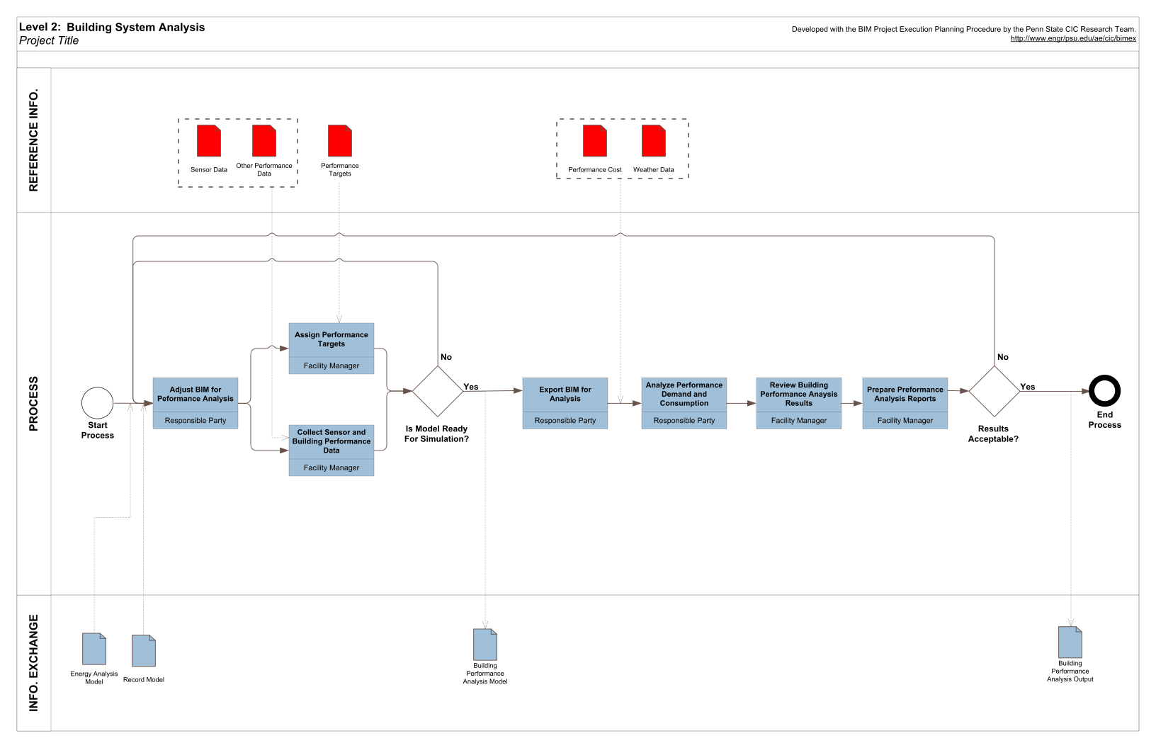

Output

Output

Description

A process that measures how a building's performance compares to the specified design. This includes how the mechanical system operates and how much energy a building uses. Other aspects of this analysis include, but are not limited to, ventilated facade studies, lighting analysis, internal and external CFD airflow, and solar analysis.

Potential Value

* Ensure building is operating to specified design and sustainable standards
* Identify opportunities to modify system operations to improve performance
* Create a "what if" scenario and change different materials throughout the building to show better or worse performance conditions

Resources Required

* Building Systems Analysis Software (Energy, Lighting, Mechanical, Other)

Team Competencies Required

* Ability to understand and manipulate CMMS and building control systems with Record Model
* Ability to understand typical equipment operation and maintenance practices
* Ability to manipulate, navigate, and review a 3D Model

References for Additional Information

Ayat E. Osman, Robert Ries. " Optimization For Cogeneration Systems in Buildings Based on Life Cycle Assessment" May 2006, http://itocn.org/2006/20/

"Building Performance Analysis Using Revit" 2007 Autodesk Inc., <http://images.autodesk.com/adsk/files/building_performance_analysis_using_revit.pdf>

Potential Output Information

Source:  BIM Project Execution Planning Guide, Ver. 2.2 with minor revisions.

## 21: Asset Management

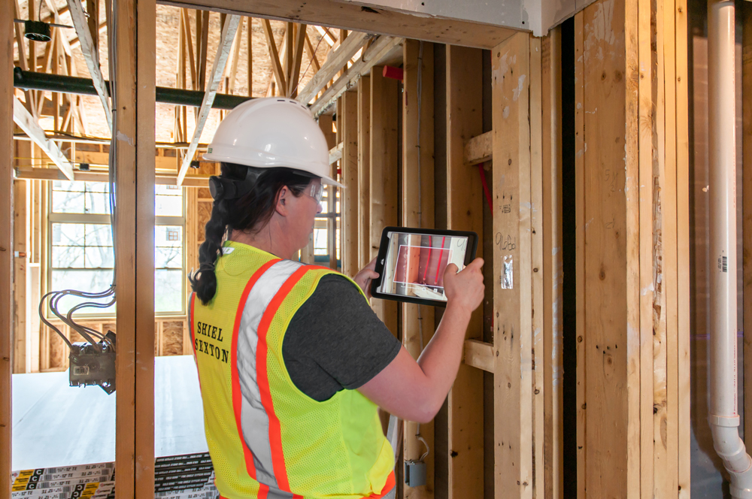

Description

A process in which an organized management system is bi-directionally linked to a record model to efficiently aid in the maintenance and operation of a facility and its assets. These assets, consisting of the physical building, systems, surrounding environment, and equipment, must be maintained, upgraded, and operated at an efficiency which will satisfy both the owner and users in the most cost effective manner. It assists in financial decision-making, short-term and long-term planning, and generating scheduled work orders. Asset Management utilizes the data contained in a record model to populate an asset management system which is then used to determine cost implications of changing or upgrading building assets, segregate costs of assets for financial tax purposes, and maintain a current comprehensive database that can produce the value of a company's assets. The bi-directional link also allows users to visualize the asset in the model before servicing it potentially reducing service time.

Potential Value

* Store operations, maintenance owner user manuals, and equipment specifications for faster access.
* Perform and analyze facility and equipment condition assessments
* Maintain up-to-date facility and equipment data including but not limited to maintenance schedules, warranties, cost data, upgrades, replacements, damages/deterioration, maintenance records, manufacturer's data, and equipment functionality
* Provide one comprehensive source for tracking the use, performance, and maintenance of a building's assets for the owner, maintenance team, and financial department
* Produce accurate quantity takeoffs of current company assets which aids in financial reporting, bidding, and estimating the future cost implications of upgrades or replacements of a particular asset.
* Allow for future updates of record model to show current building asset information after upgrades, replacements, or maintenance by tracking changes and importing new information into model.
* Aid financial department in efficiently analyzing different types of assets through an increased level of visualization
* Increase the opportunity for measurement and verification of systems during building occupation
* Automatically generate scheduled work orders for maintenance staff.

•

References for Additional information

CURT. (2010) BIM Implementation: An Owner's Guide to Getting Started

NIST (2007) General Buildings Information Handover Guide: Principles, Methodology, and Case Studies<http://www.fire.nist.gov/bfrlpubs/build07/PDF/b07015.pdf>

Potential Output Information

* Asset management reports
* Asset management revisions for BIM

Source:  BIM Project Execution Planning Guide, Ver. 2.2 with minor revisions.

## 22: Space Management

Description

A process in which BIM is utilized to effectively distribute, manage, and track appropriate spaces and related resources within a facility. A facility building information model allows the facility management team to analyze the existing use of the space and effectively apply transition planning management towards any applicable changes. Such applications are particularly useful during a project's renovation where building segments are to remain occupied. Space Management and Tracking ensures the appropriate allocation of spatial resources throughout the life of the facility. This use benefits from the utilization of the record model. This application often requires integration with spatial tracking software.

Potential Value

* More easily identify and allocate space for appropriate building use
* Increase the efficiency of transition planning and management
* Proficiently track the use of current space and resources
* Assist in planning future space needs for the facility

Resources Required

* Bi-directional 3D Model Manipulation; software and record model integration
* Space mapping and management input application

Team Competencies Required

* Ability to manipulate, navigate, and review record model
* Ability to assess current space and assets and mange appropriately for future needs
* Knowledge of facility management applications
* Ability to effectively integrate the record model with the Facility Management's Application and appropriate software associated with the client's needs.

References for Additional Information

Jason Thacker "Total Facilities Management." 2010. 19 Sept. 2010. Technology Associates International Corporation. Web. 19 Sept. 2010, <http://proceedings.esri.com/library/userconf/proc04/docs/pap1519.pdf>.

Mapping Your Facilities Management Future. Aug. 2009 Web. 19 Sept. 2010. Acatech Solutions, <https://www.avatech.com/solutions/facilities-management/facilities-management-whitepapers.aspx>.

Vacik, Nocolas A. and Patricia Huesca-Dorantes. "building a GIS Database for Space and Facilities Management." New Directions for Institutional Research, n120 p53-61 2003.

Potential Output Information

* Space management reports
* Space management data

Source:  BIM Project Execution Planning Guide, Ver. 2.2 with minor revisions.

## 23: Disaster Planning and Mitigation

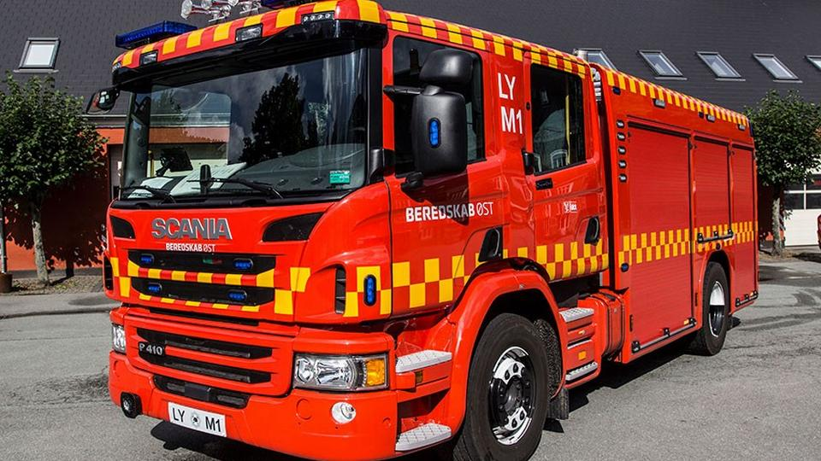

Description

A process in which emergency responders access critical building information in the form of a model and information system to plan for and manage extreme events. The BIM provides critical information to the responders to improve the efficiency of the response and minimize safety risks. The real time building information from a building automation system (BAS), along with the static building information, such as floor plans and equipment schematics, can be valuable information in the model. These systems can integrate via a wireless connection and emergency responders can link to an overall system. The BIM coupled with the BAS can display location information regarding emergencies, possible routes to the area, and any other harmful locations within the building.

Potential Value

* Provide police, fire, public safety officials, and first responders access to critical building information in real-time
* Improve the effectiveness of emergency response
* Minimize risks to responders

Resources Required

* Design review software to view Record Model and components
* Building Automation System (BAS) linked to model data
* Computerized Maintenance Management System (CMMS) linked to model data

Team Competencies Required

* Ability to manipulate, navigate, and review BIM model for facility updates
* Ability to understand dynamic building information through BAS
* Ability to make appropriate decisions during an emergency

References for Additional Information

Building Information for Emergency Responders. Systemics, Cybernetics and Informatics, 11th World Multi-Conference (WMSCI 2007). Proceedings. Volume 3. Jointly with the Information Systems Analysis and Synthesis: ISAS 2007, 13th International Conference. July 8-11, 2007, Orlando, FL, Callaos, N.; Lesso, W.; Zinn, C. D.; Yang, H., Editor(s ) (s), 1-6 pp, 2007. Treado, S. J.; Vinh, A.; Holmberg, D. G.; Galler, M.

Potential Output Information

* under development

Source:  BIM Project Execution Planning Guide, Ver. 2.2 with minor revisions.

Phases

BIM Use Purpose Characteristic: Facility Phase

After determining the discipline, the planning team should determine during which facility phase they will be implementing the BIM Use. Facility phase designation often results in multiple BIM uses and multiple disciplines. For example, the design team may be responsible for coordination analysis during the design phase and the construction team may be responsible for the coordination analysis during the construction phase.

If project team does not have phase predetermined, it is suggested in the Penn State guide that the team use [OmniClass Table 31: Phases](https://www.csiresources.org/standards/omniclass) to designate phases: These current phases within this table include:

* 10) Inception Phase,
* 20) Conceptualization Phase,
* 30) Criteria Definition Phase,
* 40) Design Phase,
* 50) Coordination Phase,
* 60) Implementation Phase,
* 70) Handover Phase,
* 80) Operations Phase,
* 90) Closure Phase

# ISO 19650 Process

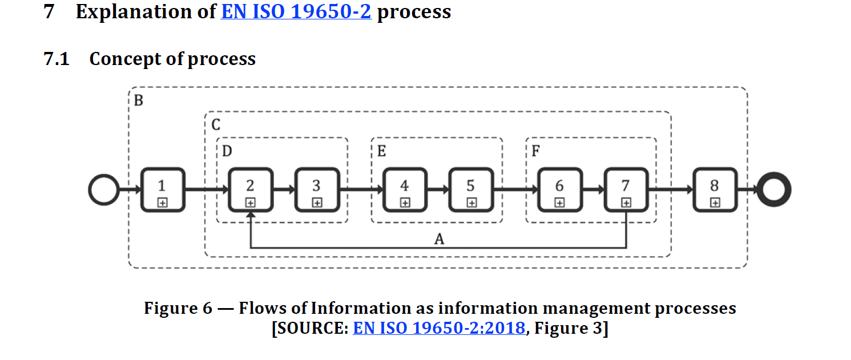

1 Assessment and need (Appointing party)

what do we need from the service

Appointing party needs: output of process.

2 Invitation to tender

specify the exact needs and put out tender

Specify the exact needs of the output.

3 Tender response (Next week)

receive responses from companies

4 Appointment

5 Mobilization

6 Collaborative production of information

candidate for automation.

IDM can help…

7 Information model delivery

8 project close-out (end of delivery)

This as BPMN.js

## Assessmnet and need

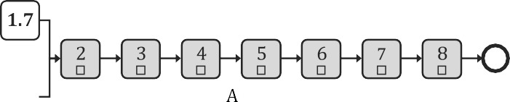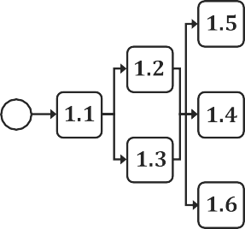

* CDE is both the process for collecting and managing the data and the technology that supports this.

## Invitation to Tender

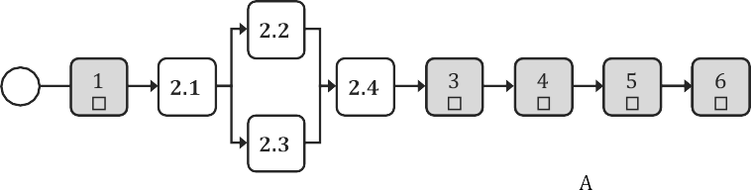

## Tednder Reposne

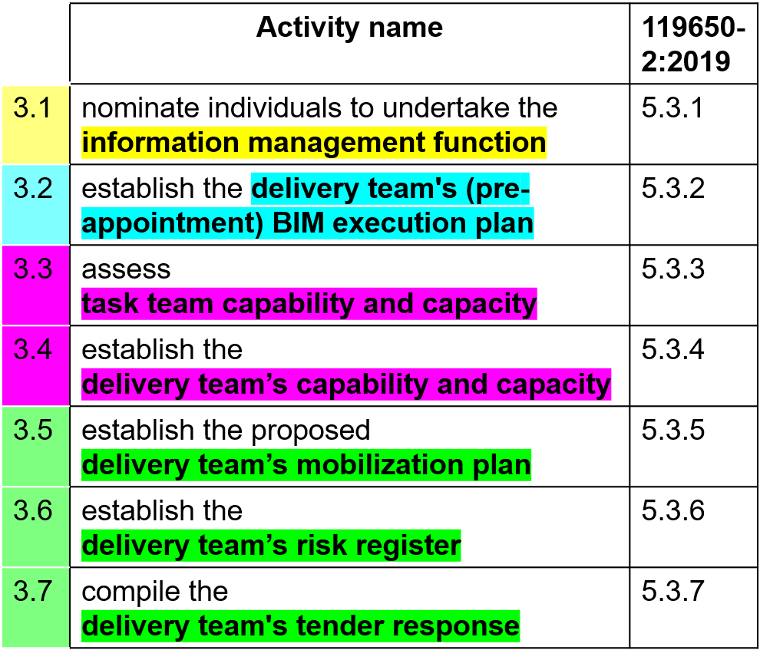

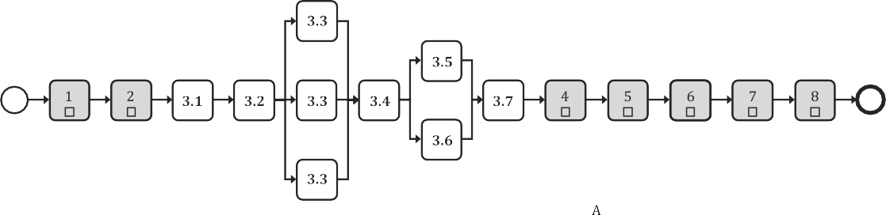

## Appointment

* Appointing the service *p*rovider

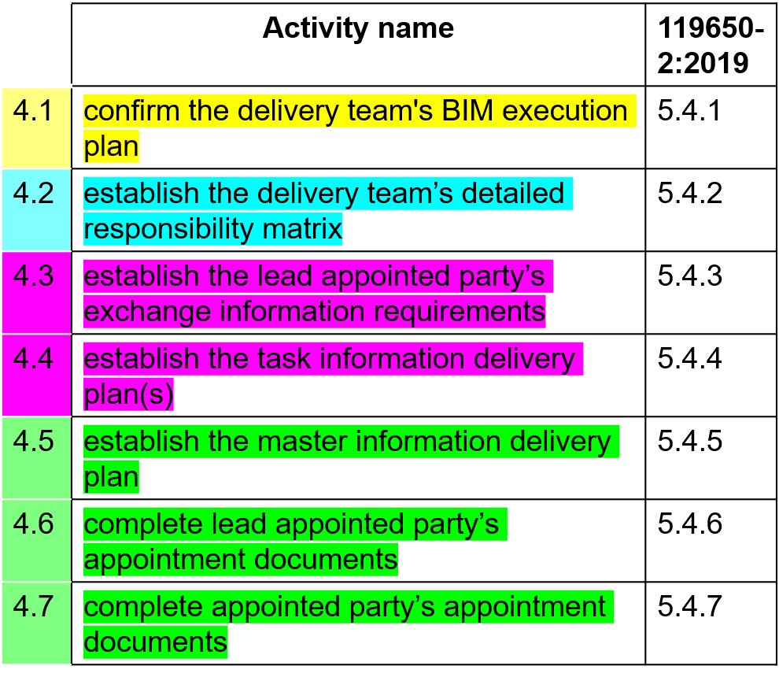

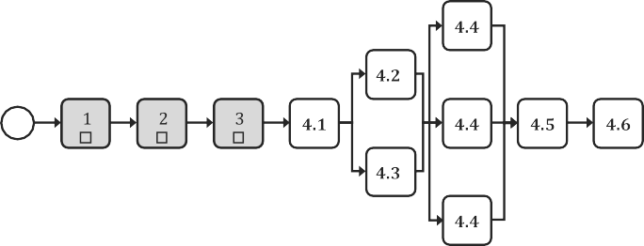

## Mobilisation

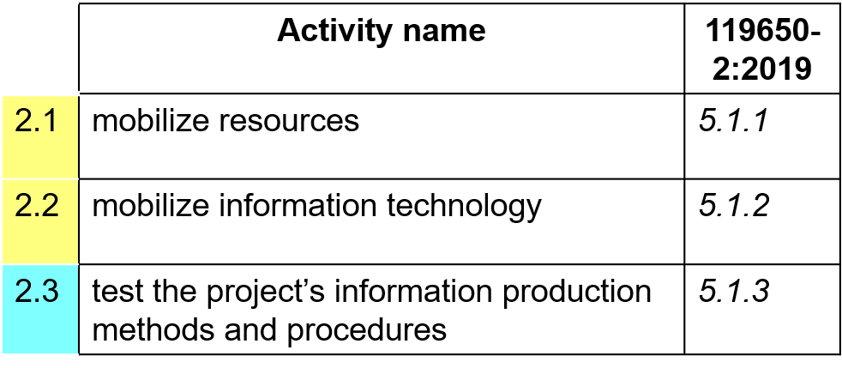

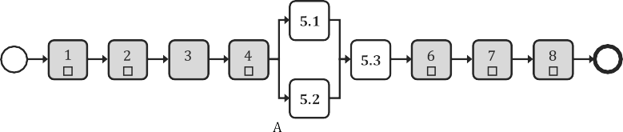

# Collaborative Production of Info

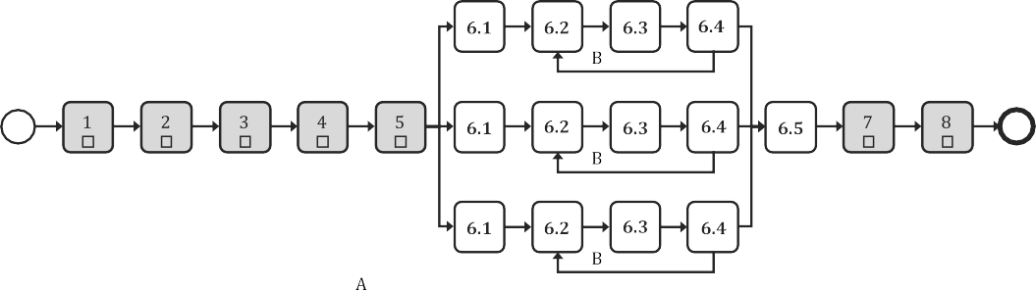

## Inofromation Model Delivery

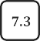

## Project Close Out

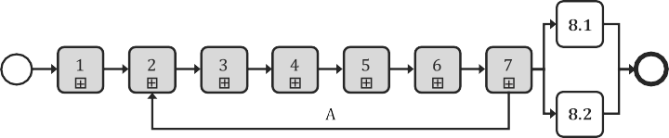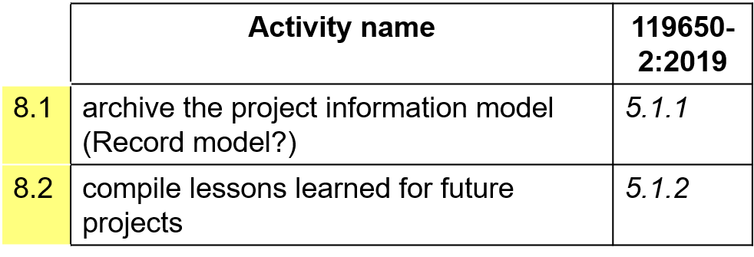

# Information Delivery Manual

**ISO 29481-1:2016**

Three approaches to IDM development

1. Process Discovery
2. Information Constraint Customisation
3. Reverse Engineering

Process Discovery

IFC 2x Edition 3 Model Implementation Guide

Information here

Main page here:

<https://standards.buildingsmart.org/documents/IDM/IDM_guide-CompsAndDevMethods-IDMC_004-v1_2.pdf>

Basic guide to IDM:

<https://www.bimloket.nl//documents/BIM_basis_ILS_v1_0_ENG.pdf>

IDM Phases

|  |  |  |  |
| --- | --- | --- | --- |
| ISO 22263 name | Standard stage | Standard name | Standard definition |
| PLAN : Pre-life cycle stages | | | |
| Inception | 0 | Portfolio requirements | Establish the need for a project to satisfy the clients business requirement |
| Brief | 1 | Conception of need | Identify potential solutions to the need and plan for feasibil­ity |
| 2 | Outline feasibility | Examine the feasibility of options presented in phase 1 and decide which of these should be considered for substantive feasibility |
| 3 | Substantive feasibility | Gain financial approval |
| DESIGN: Pre-Construction stages | | | |
| Design | 4 | Outline conceptual design | Identify major design elements based on the options present­ed |
| 5 | Full conceptual design | Conceptual design and all deliverables ready for detailed planning approval |
| 6 | Coordinated design (and procurement) | Fix all major design elements to allow the project to proceed. Gain full financial approval for the project |
| BUILD: Construction stages | | | |
| Production | 7 | Production Information | Finalise all major deliverables and proceed to construction. |
| 8 | Construction | Produce a product that satisfies all client requirements.  Handover the building as planned. |
| RE/USE: Post-construction stages | | | |
| Maintenance | 9 | Operation and maintenance | Operate and maintain the product effectively and efficiently. |
| Demolition | 10 | Disposal | Decommission, dismantle and dispose of the components of the project and the project itself according to environmental and health/safety rules |

# MVD